|  |  |  |  |
| --- | --- | --- | --- |
|  | | **DS 2022** | |
| Data Science Project | | | |
| **Team nr:** 12 | **Student 1 :** Eduardo Moreira Miranda | | **IST nr:** 95569 |
| **Student 2 :** Miguel Paraíso Alves | | **IST nr:** 95650 |
| **Student 3 :** Rodrigo De Melo Pinto | | **IST nr:** 95666 |

This document presents a template for the Data Science Project report. It specifies the mandatory format and suggests the structure to follow. All text with grey background shall be replaced with the analysis made over the datasets.

Classification

# Data Profiling

In the both datasets we used our domain knowledge to drop and encode variables, for example in dataset 1 we dropped the payer_code column because it is irrelevant for the task at hand.

## Data Dimensionality

In both datasets the number of records is way bigger than the dimensionality making them low sparsity, so we can cover all the domain.

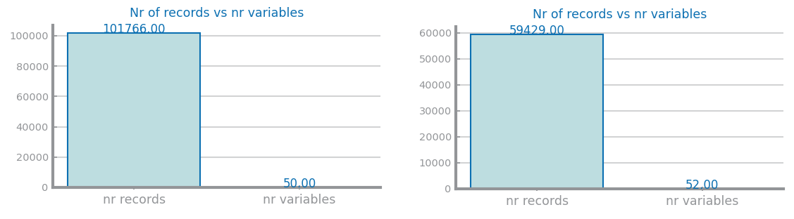

Figure 1 Nr Records x Nr variables for dataset 1 (left) and dataset 2 (right)

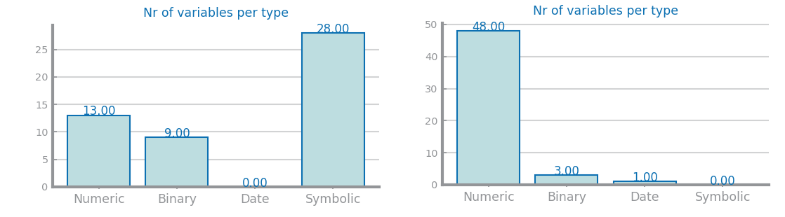

Figure 2 Nr variables per type for dataset 1 (left) and dataset 2 (right)

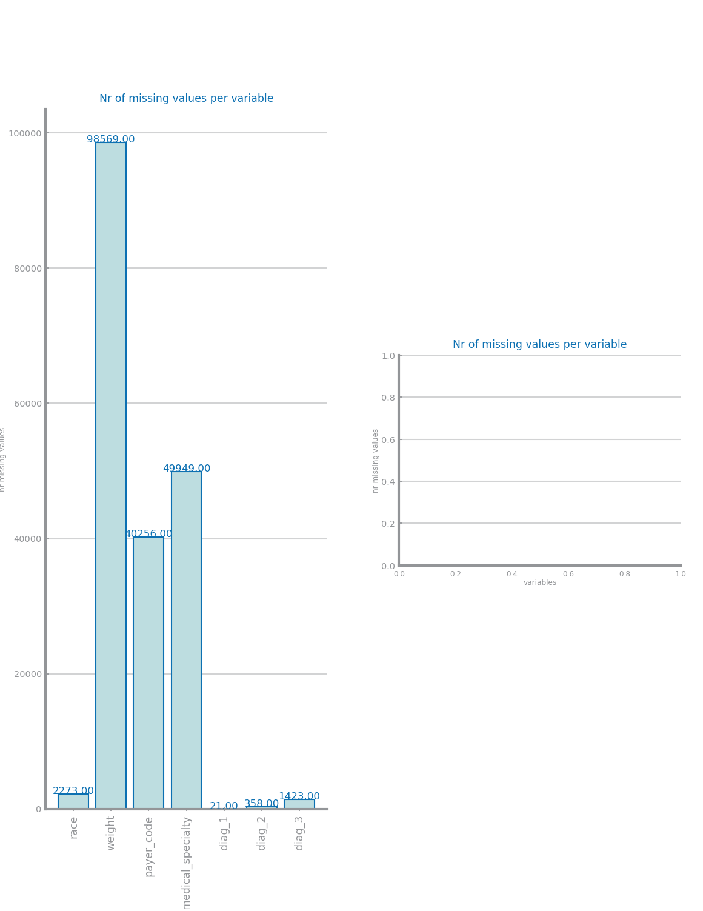

Figure 3 Nr missing values for dataset 1 (left) and dataset 2 (right)

## Data Distribution

In dataset 1 we can see that some variables only have one value in the entire dataset, the patient_nbr and encounter_id have a bigger value distribution than the other numeric variables and most numeric variables are discrete and do not follow a normal distribution. In the dataset 2 most numeric variables follow a normal distribution and some variables like SQ5 have a distribution where one value is a lot more common than the others.

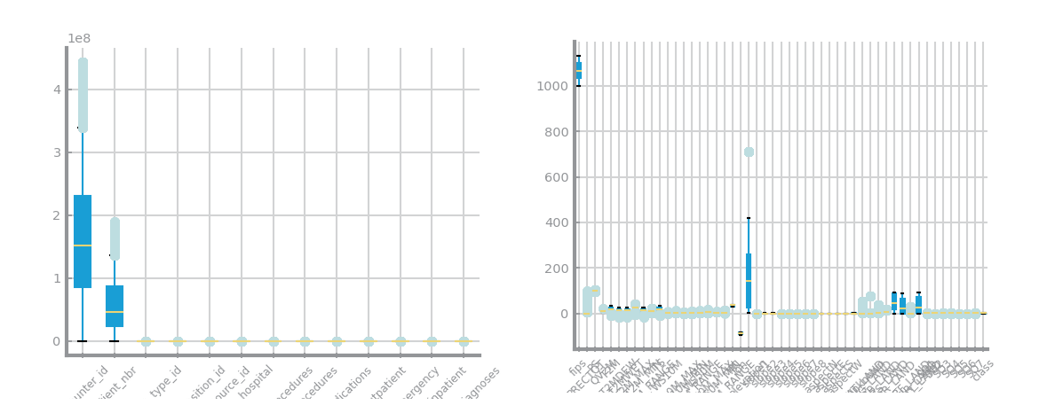

Figure 4 Global boxplots dataset 1 (left) and dataset 2 (right)

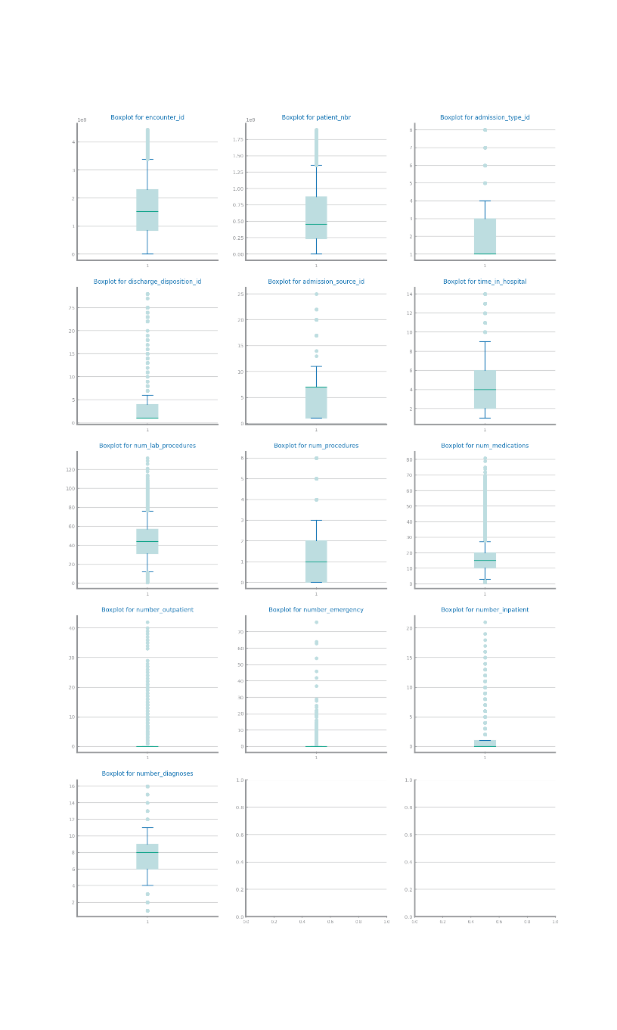

Figure 5 Single variable boxplots for dataset 1

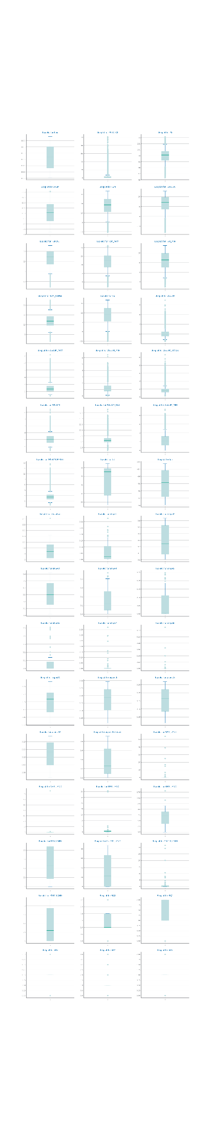

Figure 6 Single variable boxplots s for dataset 2

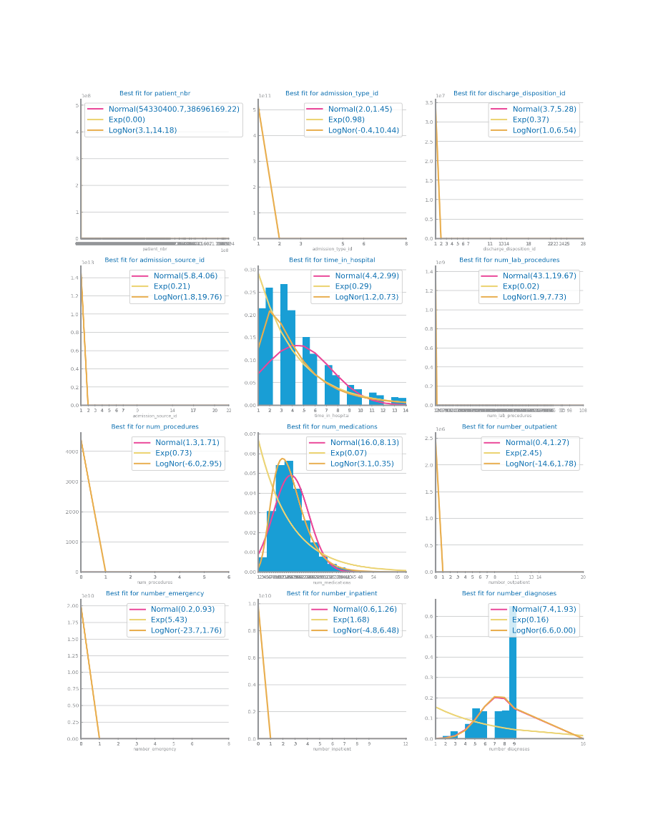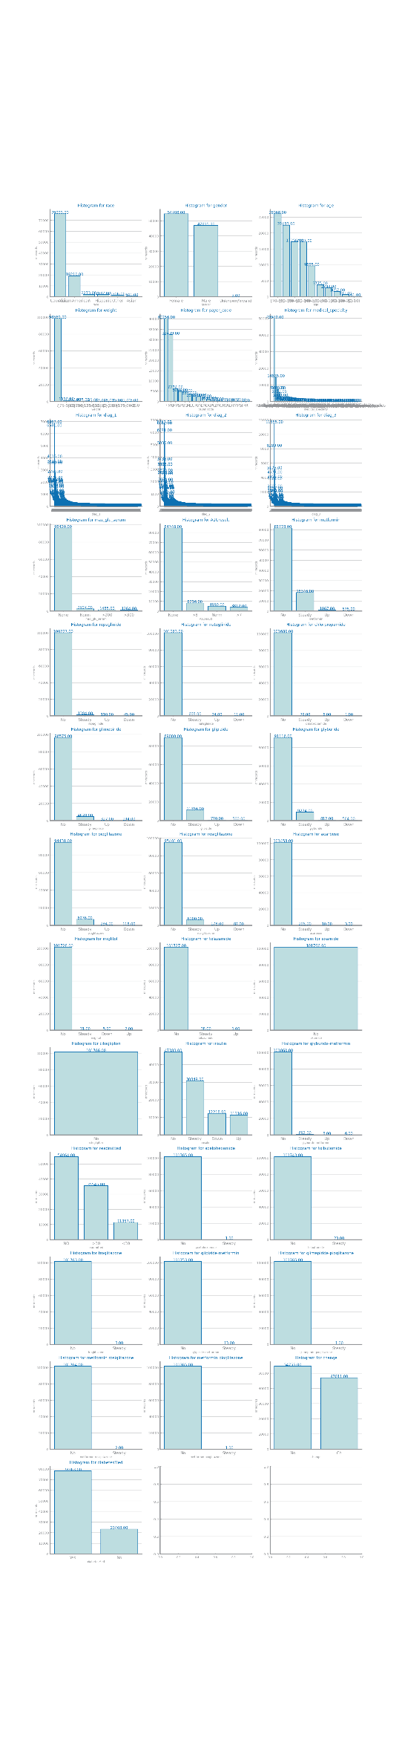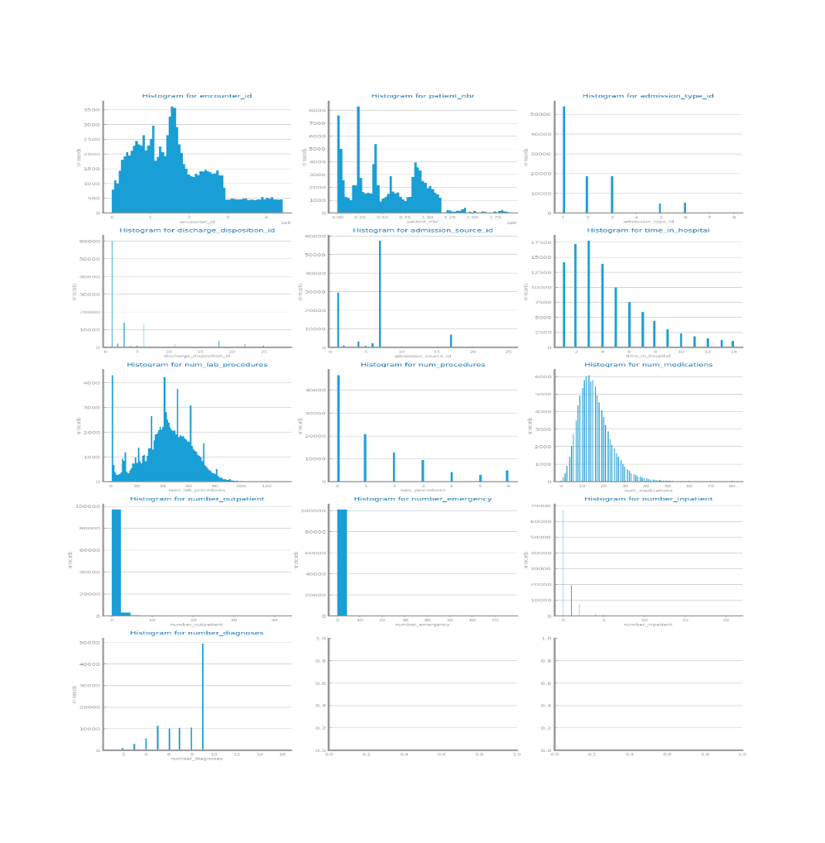

Figure 7 Histograms for dataset 1

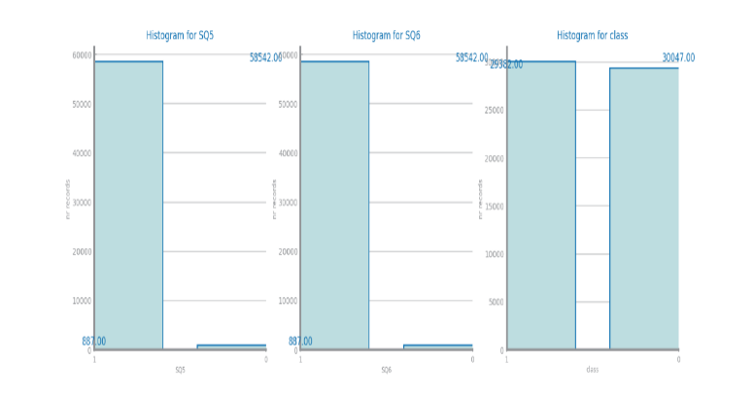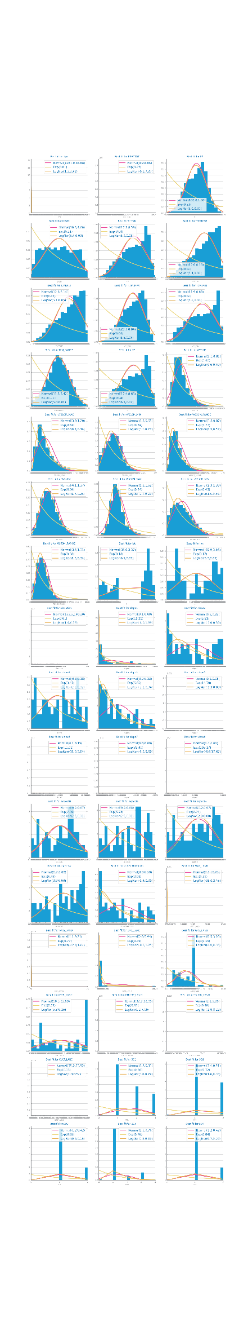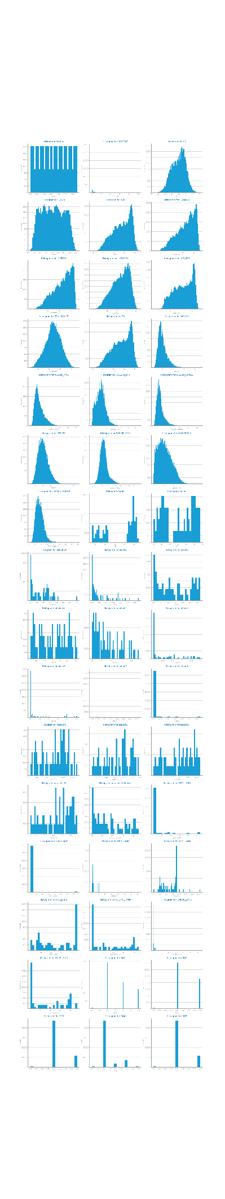

Figure 8 Histograms for dataset 2

## Data Granularity

Some variables like encounter_id on dataset 1 benefit from a higher granularity because we can see more detail however most variables have few possible values so they do not benefit from higher granularity.

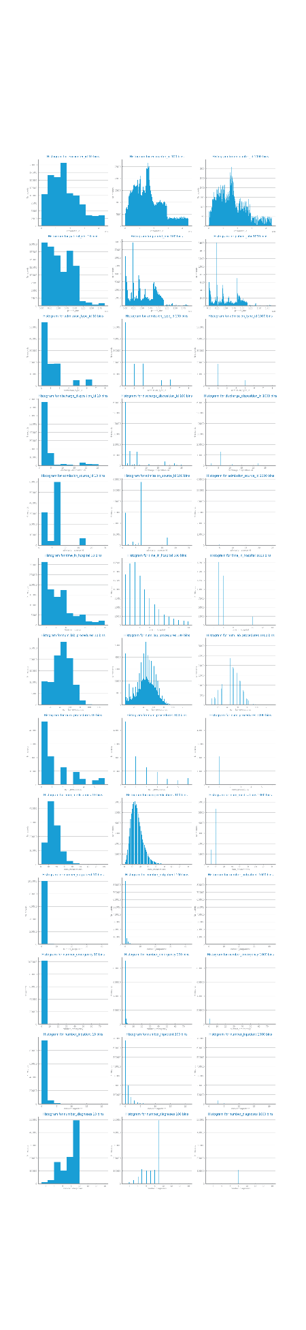

Figure 9 Granularity analysis for dataset 1

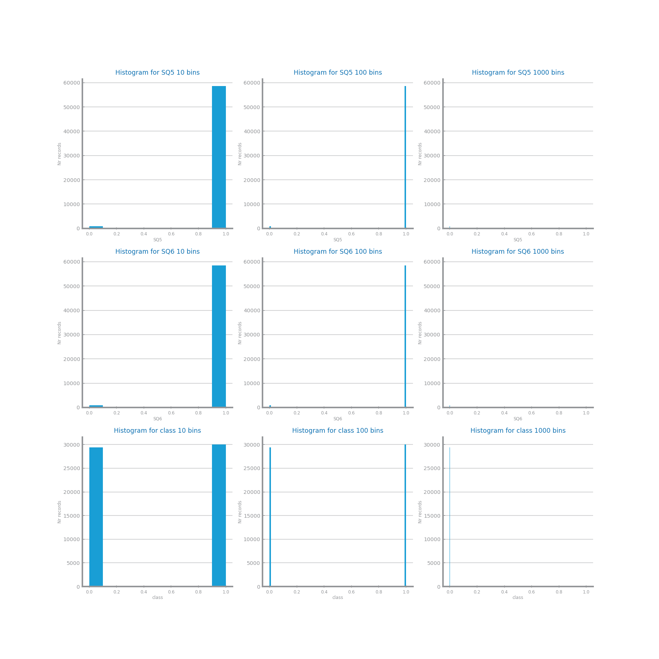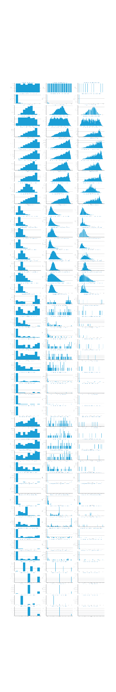

Figure 10 Granularity analysis for dataset 2

## Data Sparsity

In both dataset we have low sparsity because most values of the domain are covered. In our correlation analysis we can see that in dataset 2 there are a lot more correlations than in dataset 1. For example in dataset 2 the T2M variables are strongly correlated.

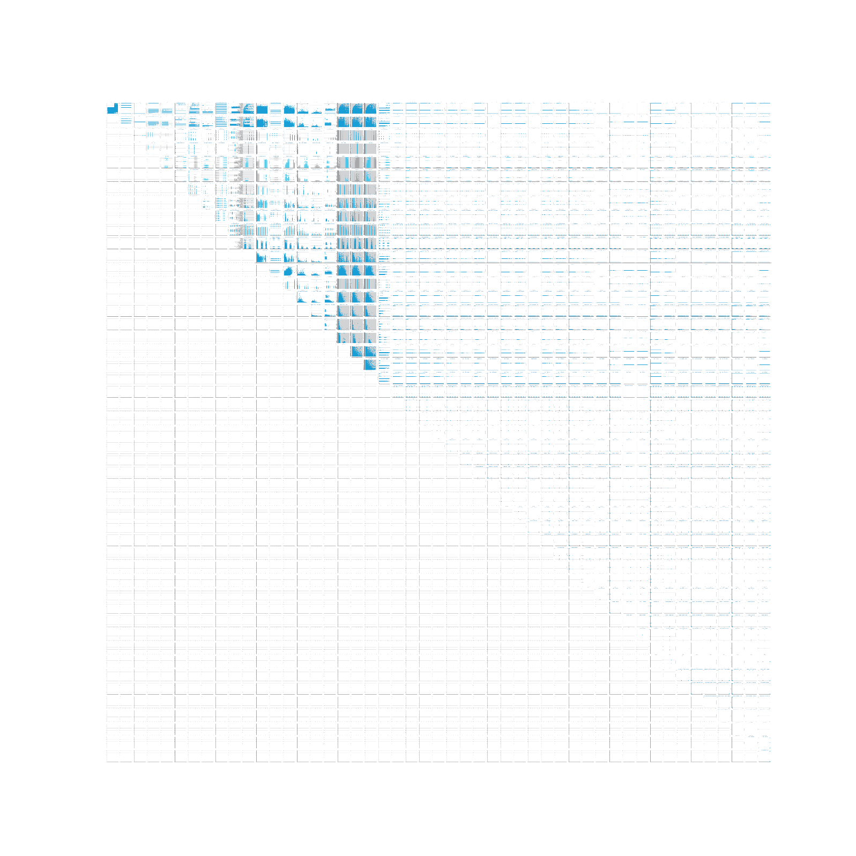

Figure 11 Sparsity analysis for dataset 1



Figure 12 Sparsity analysis for dataset 2

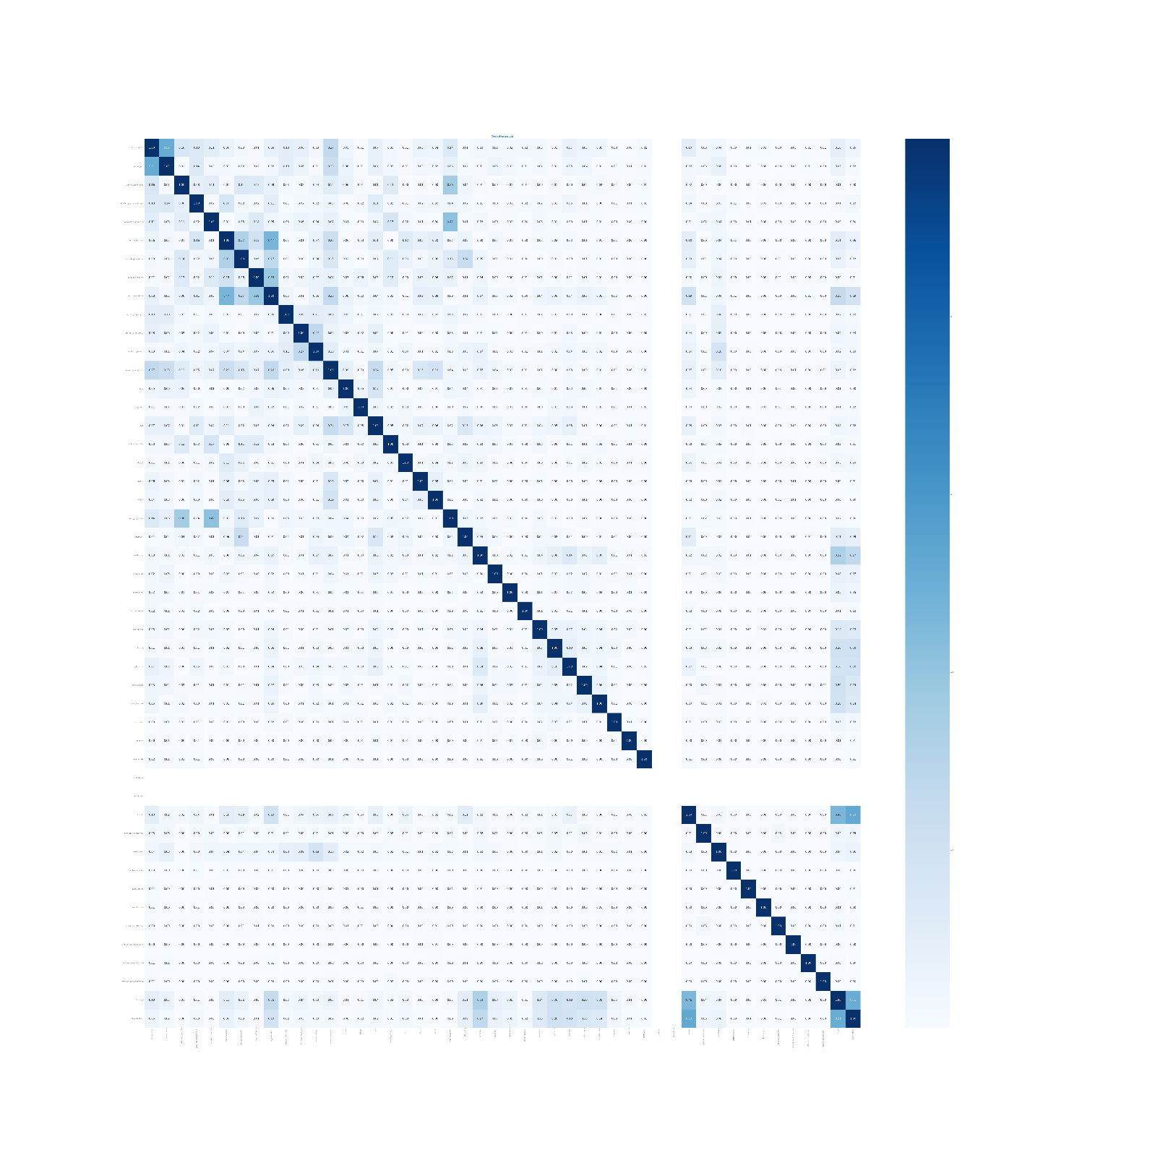

Figure 13 Correlation analysis for dataset 1

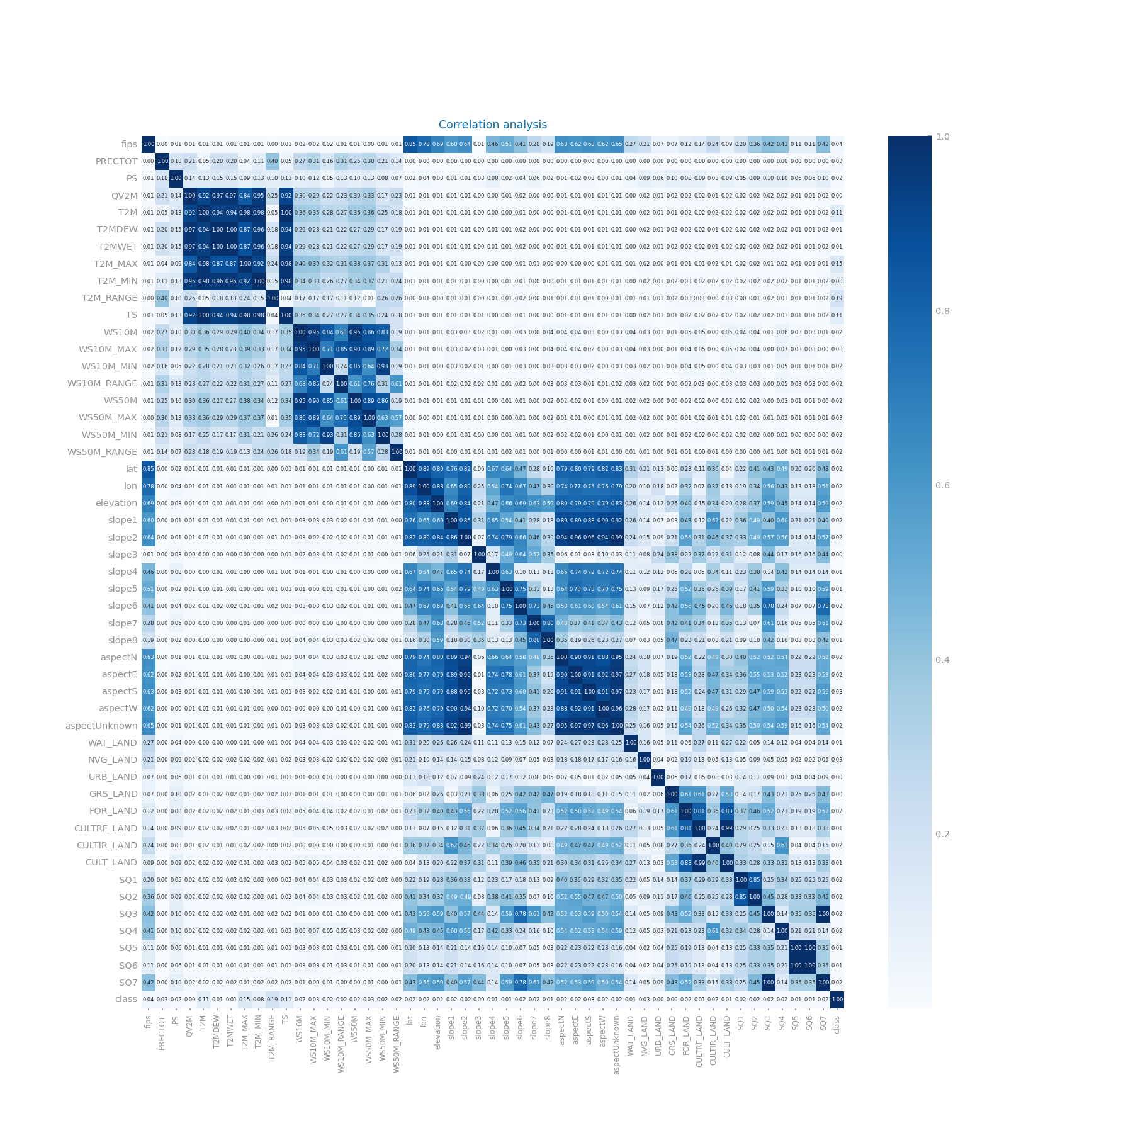

Figure 14 Correlation analysis for dataset 2

# Data Preparation

## Variables Encoding

For dataset 1 we changed most of the symbolic variables to encode in ordinal numbers example: [‘No’,’Down’,’Steady’,’Up’] is replaced by [‘0’,’1’,’2’,’3’] we did this because most of the variables have an intrinsic order to them. The only symbolic variables where we did not do this were on the diagnosis variables, here as they were already encoded numerically except for examples like ‘V57’ we just replaced ‘V’ to ‘-2.’ and ‘E’ to ‘-1.’ to preserve the variables. In dataset 2 we divided the date column into year, month and day columns so that this information could be used going forward.

## Missing Value Imputation

For dataset 1 we used two approaches and in both we dropped the weight and payer_code variables. In the first approach we replaced the missing values with a fixed value. And in the second we replaced them with the most frequent value on that variable. On dataset 2 there were no missing values so we did not do anything in this regard.

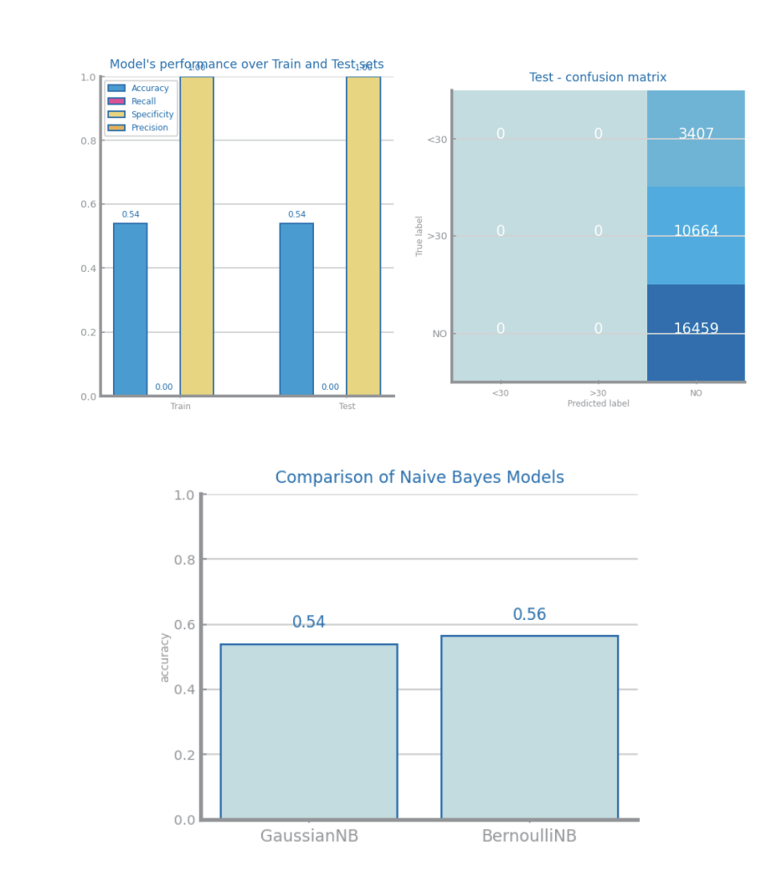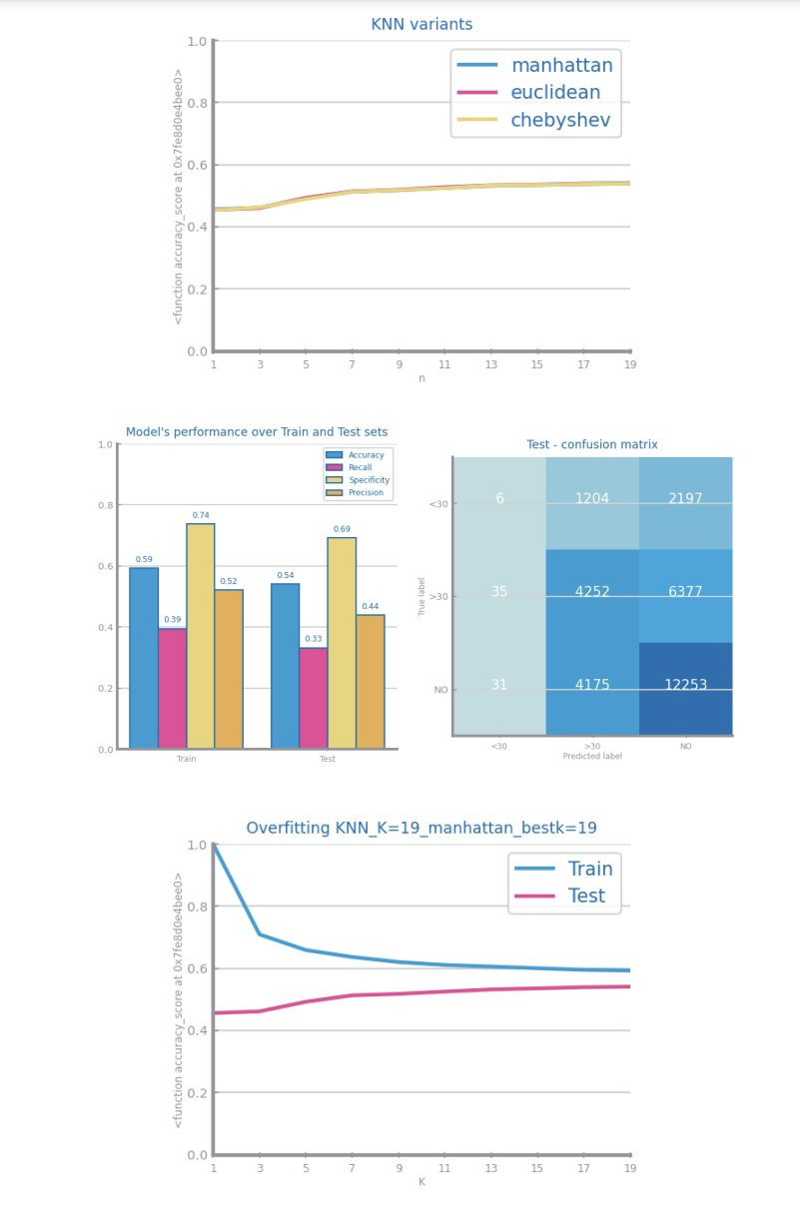

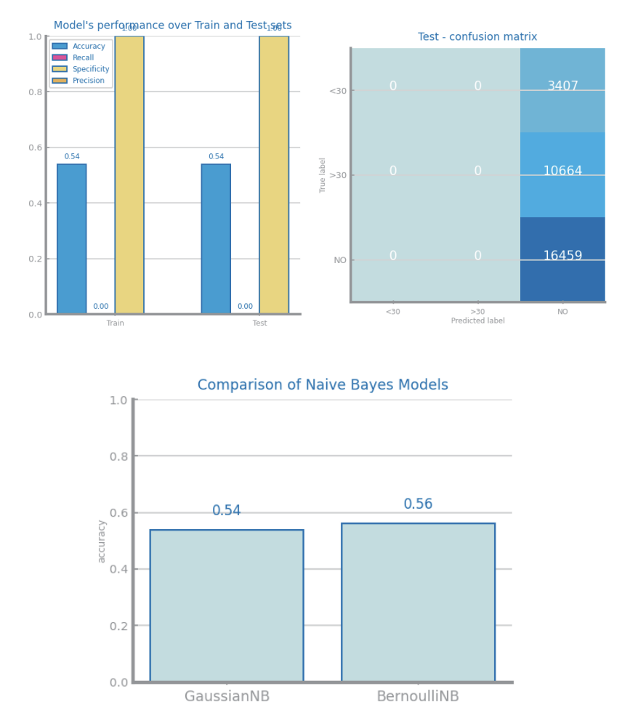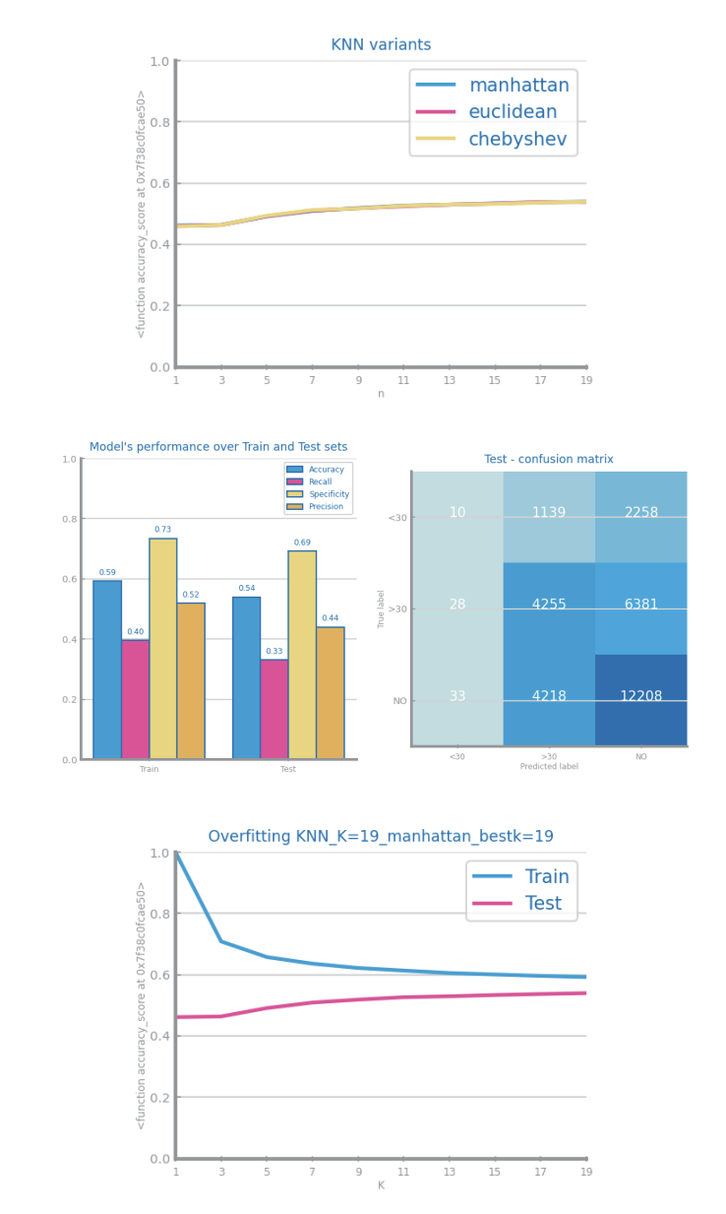

Figure 15 Missing values imputation results with different approaches for dataset 1

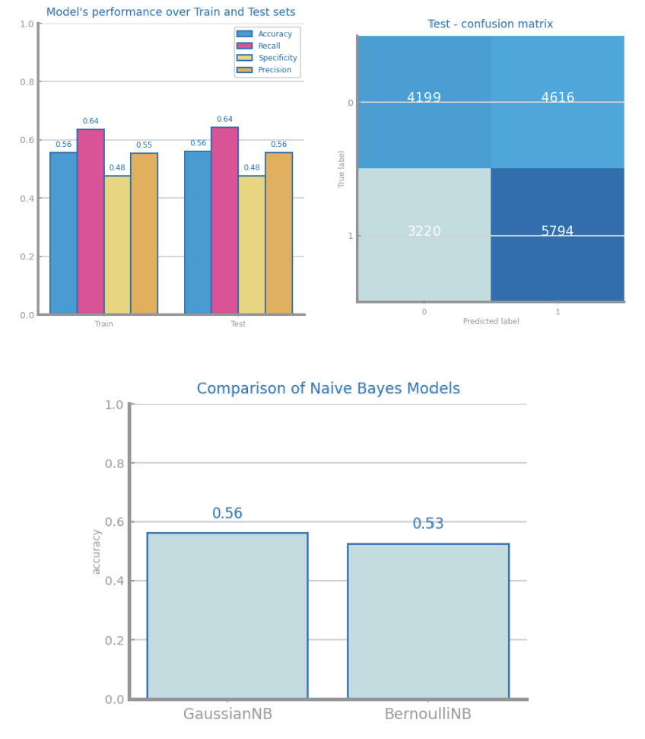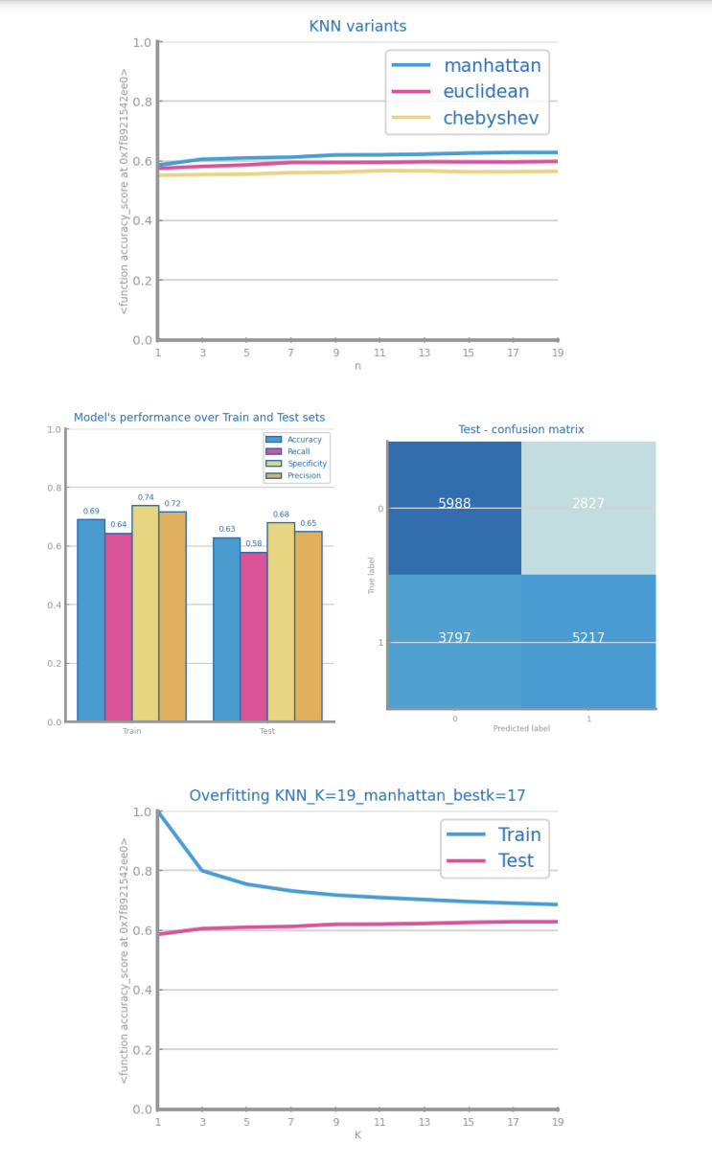

Figure 16 Missing values imputation results with different approaches for dataset 2

## Outliers Treatment

In both datasets we detected the outliers using the standard deviation method with 3 stdev as parameter, then we tested dropping the outliers (left) and truncating them (right). We chose dropping them going forward.

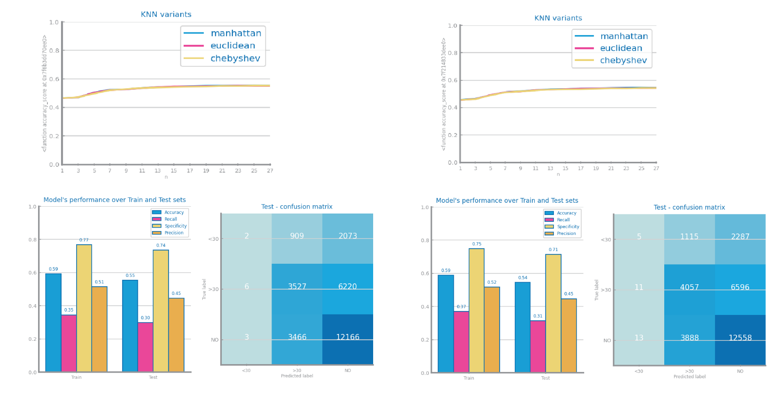

Figure 17 Outliers imputation results with different approaches for dataset 1

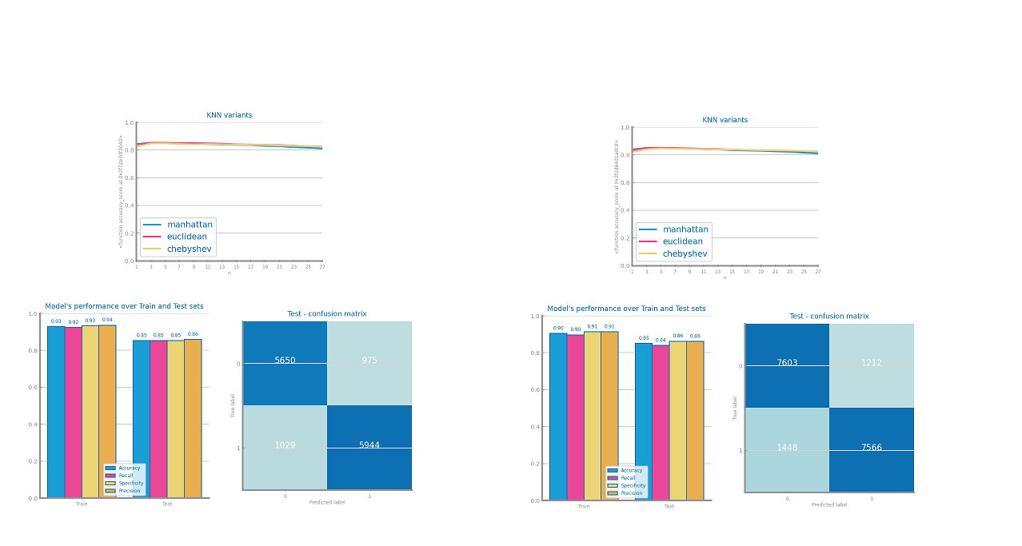

Figure 18 Outliers imputation results with different approaches for dataset 2

## Scaling

We tested both the minmax (on the left) and Z-score (on the right) on both datasets, using knn to compare the results. After comparing the accuracy we chose Z-score going forward.

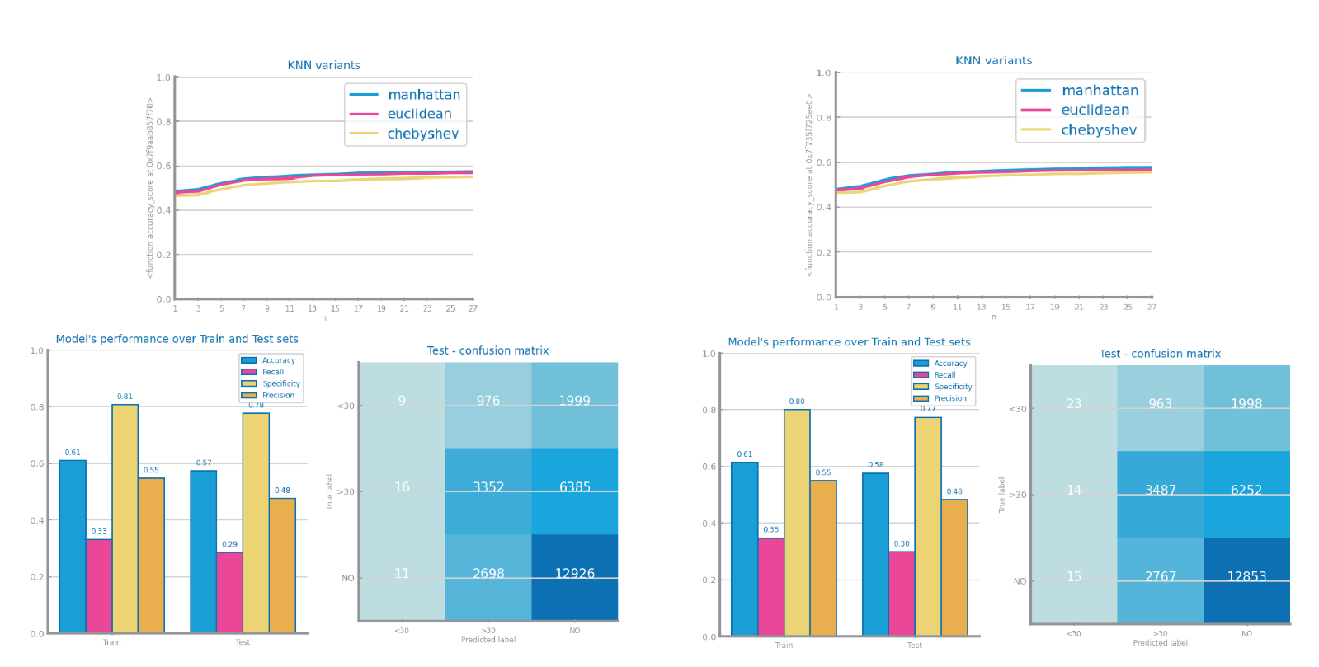

Figure 19 Scaling results with different approaches for dataset 1

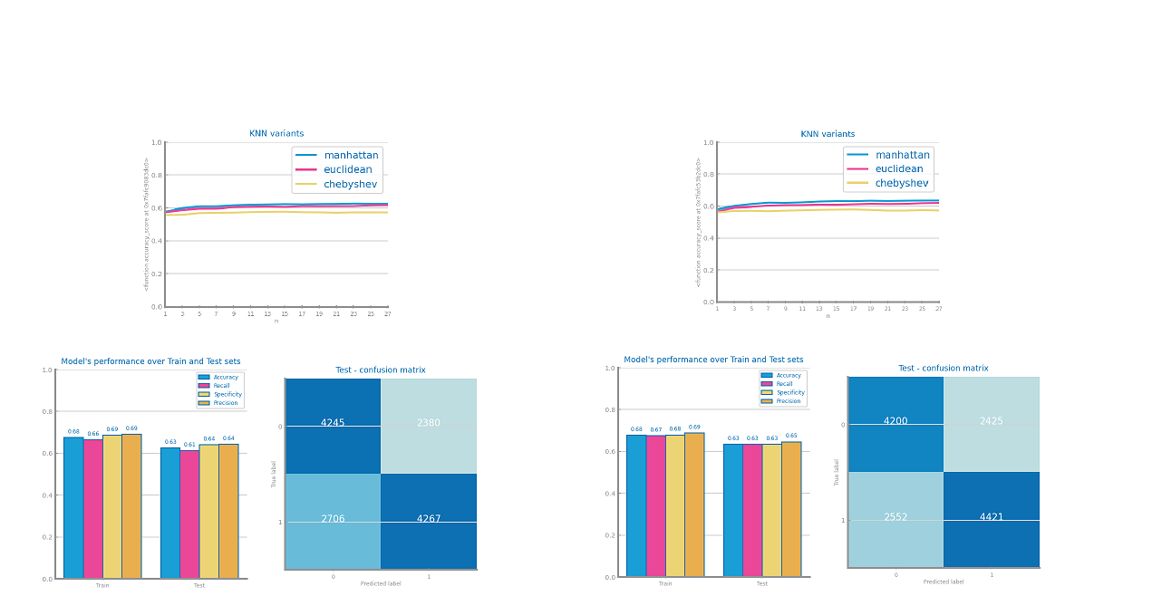

Figure 20 Scaling results with different approaches for dataset 2

## Balancing

We tested the three balancing methods on both datasets, over(right), under(center) and smote(left). After comparing the knn results we decided to choose the over method because it’s accuracy was greater than the others.

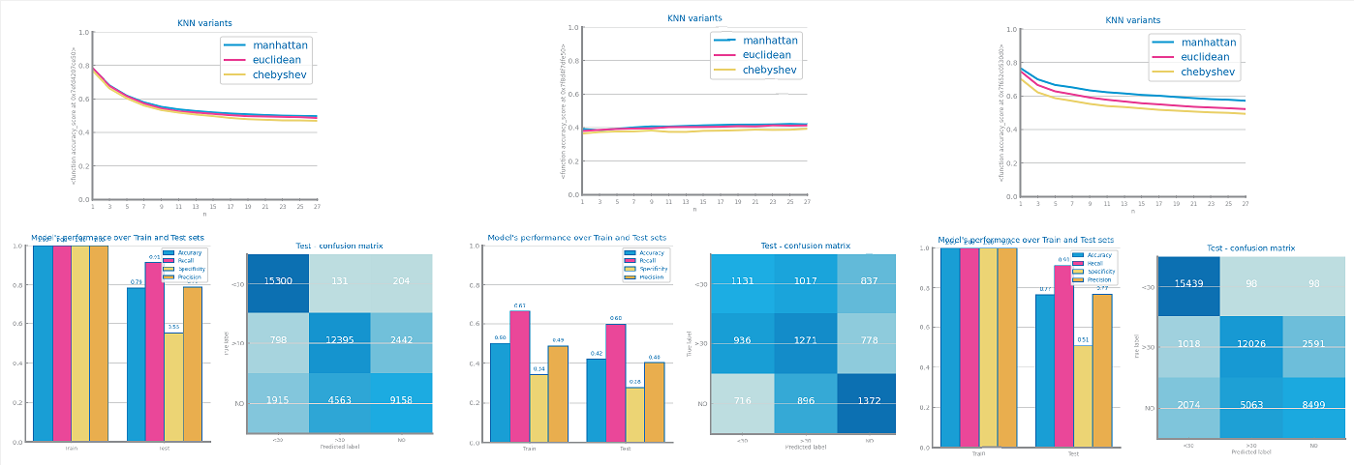

Figure 21 Balancing results with different approaches for dataset 1

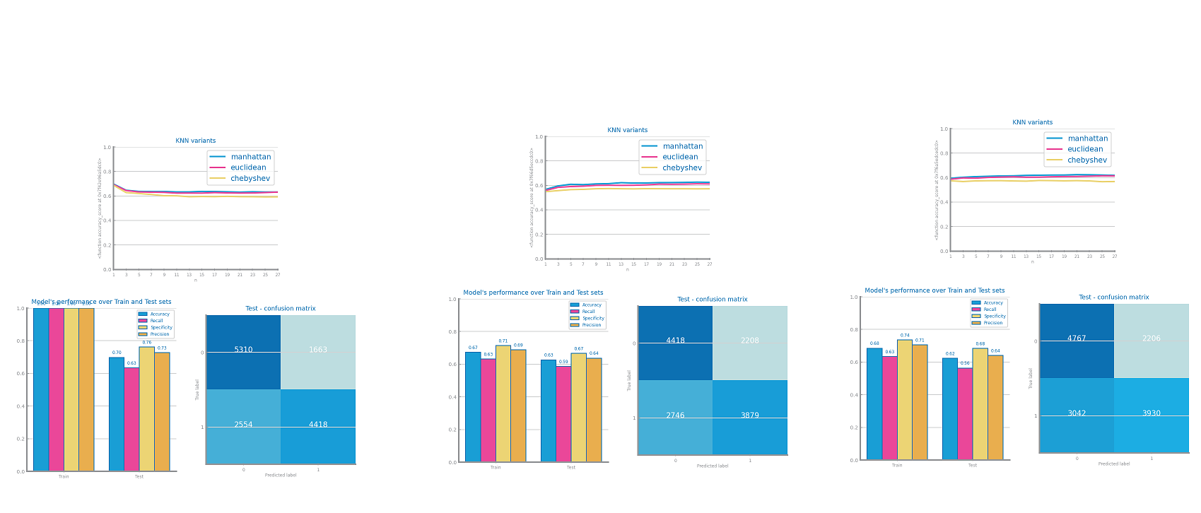

Figure 22 Balancing results with different approaches for dataset 2

## Feature Selection

For dataset 1 we dropped features that only had the same value in all records we did not drop based on correlation because there was no correlation over 90% on dataset 1. On dataset 2 we dropped features that had a correlation over 90%.

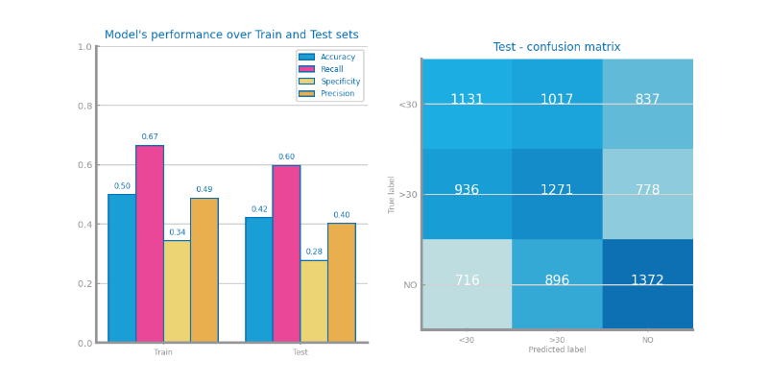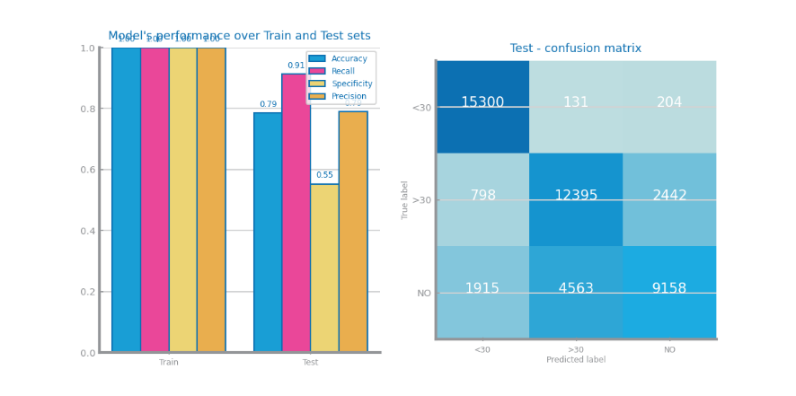

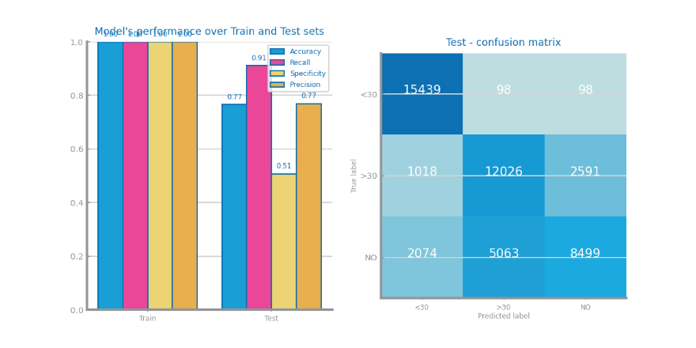

Figure 23 Feature selection of redundant variables results with different parameters for dataset 1

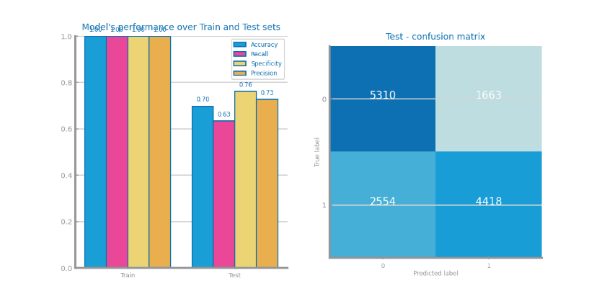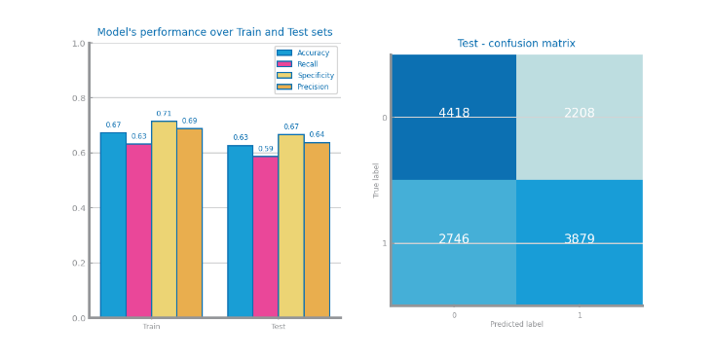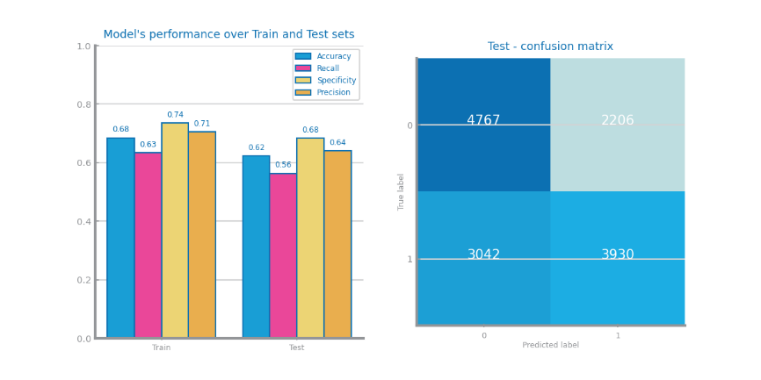

Figure 24 Feature selection of redundant variables results with different parameters for dataset 2

# Models’ Evaluation

In the model’s evaluation we used the train-test split technique with 70% of the data to train and 30% to test. To evaluate the results we used accuracy, recall, specificity and precision. For dataset 1 we considered ‘<30’ and ‘>30’ has positive values and ‘NO’ has negative values in the calculation of the evaluation metrics.

## Naïve Bayes

For both datasets we only used the Gaussian(left) and Bernoulli (right) Naïve Bayes because we had negative values in the datasets so we could not use Multinomial NB. In dataset 1 Bernoulli was better than Gaussian by a large margin in dataset 2 the two methods were almost equal.

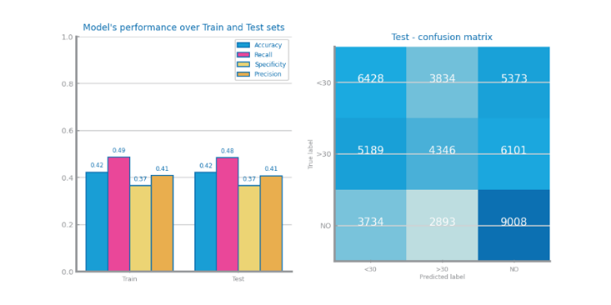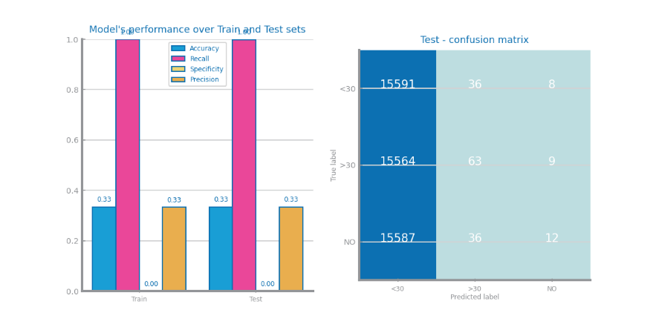

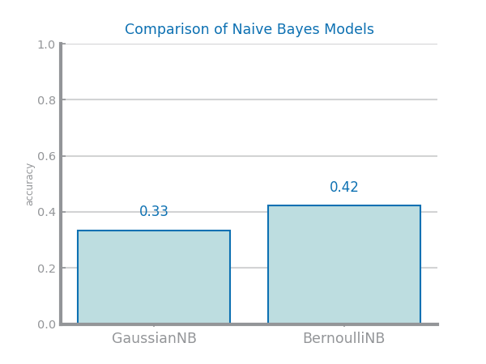

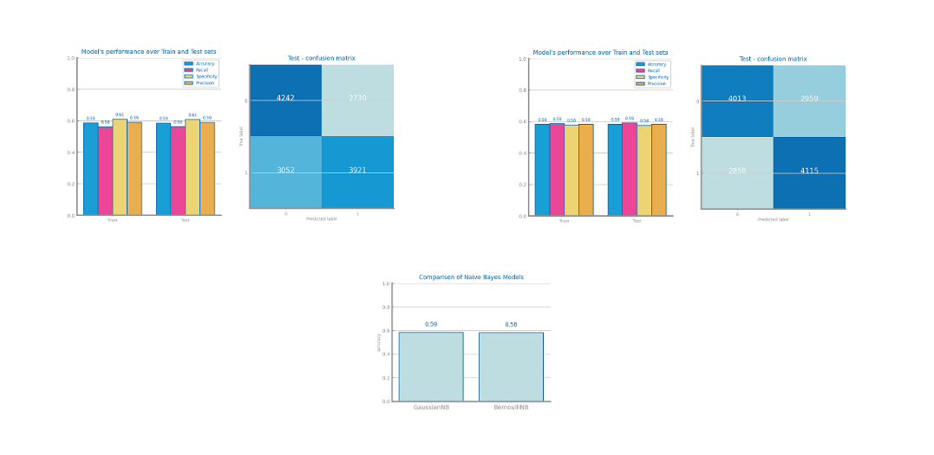Figure 29 Naïve Bayes alternatives comparison for dataset 1

Figure 30 Naïve Bayes alternative comparison for dataset 2

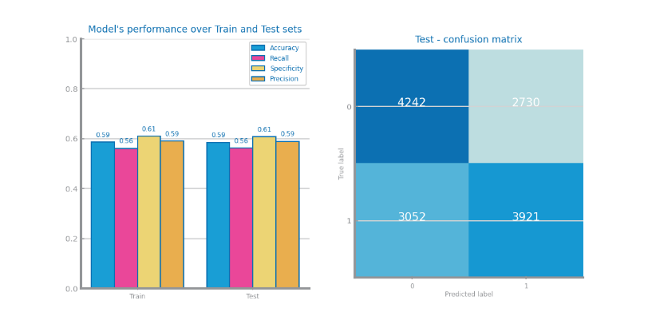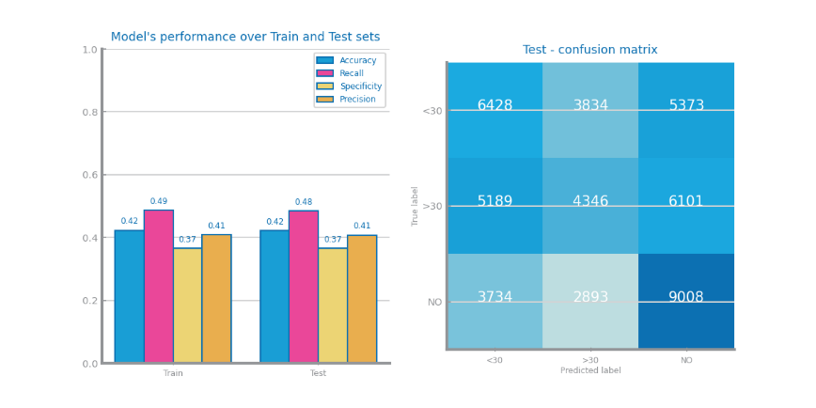

Figure 31 Naïve Bayes best model results for dataset 1 (left) and dataset 2 (right)

## KNN

In both datasets we tested with K’s in [1,..,27] and three distance methods as seen in the multiple line chart (down-right) and we show the evaluation metrics and confusion matrix with the best distance method for K=1 (up-left), K=19 (up-right) and K=27 (down-left). As we can see from the results for both datasets the best K was 1 neighbor with manhattan distance however this also makes the model with 100% accuracy to the train set which may be caused by the over balancing method. Despite this, we chose the K=1 with Manhattan has the best model because it had the bigger accuracy for the test set.

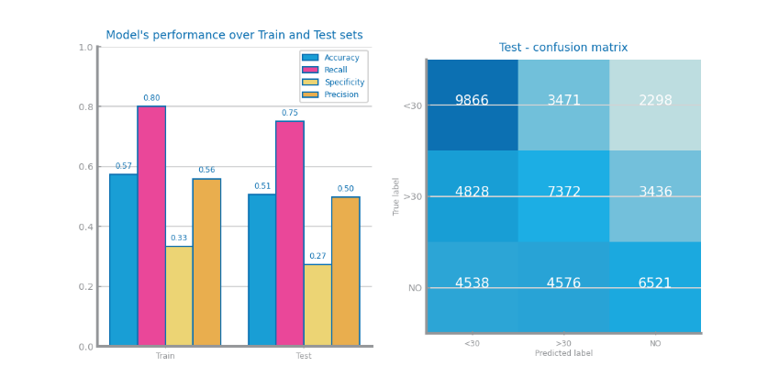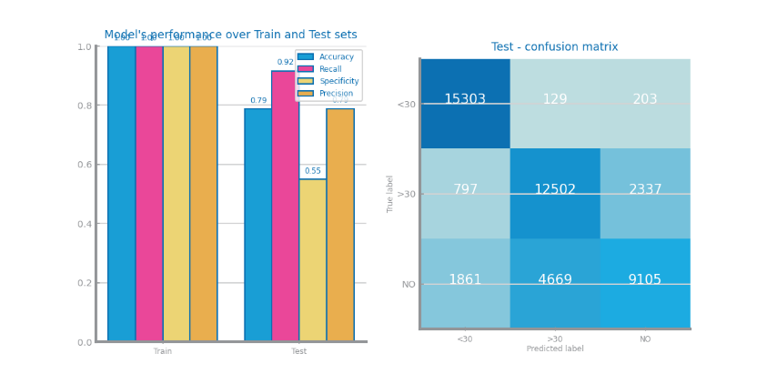

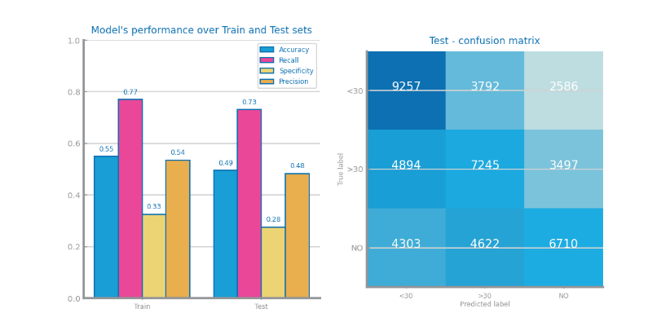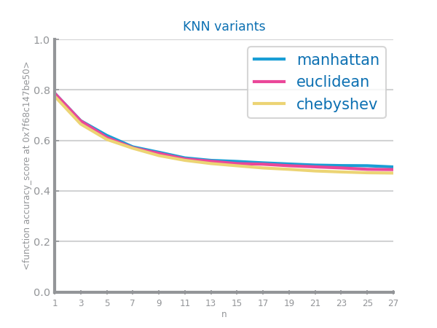

Figure 32 KNN different parameterizations comparison for dataset 1

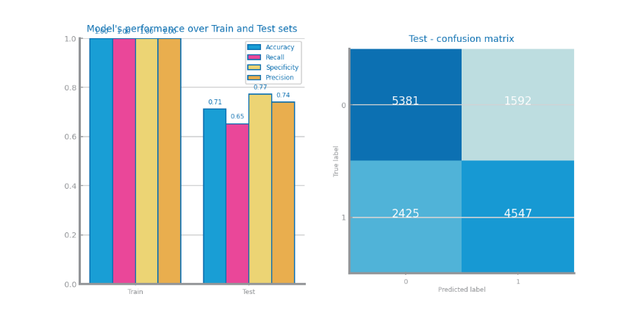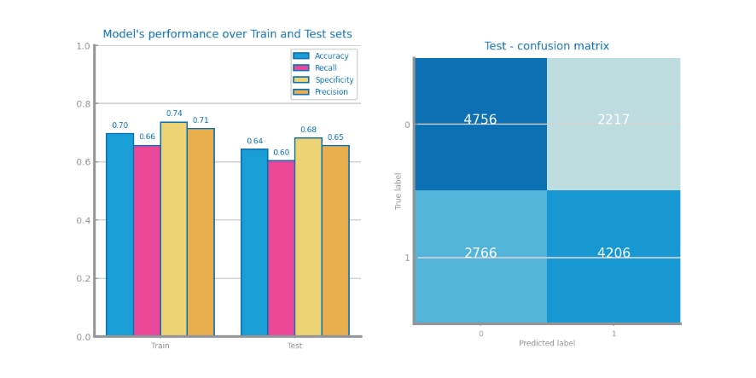

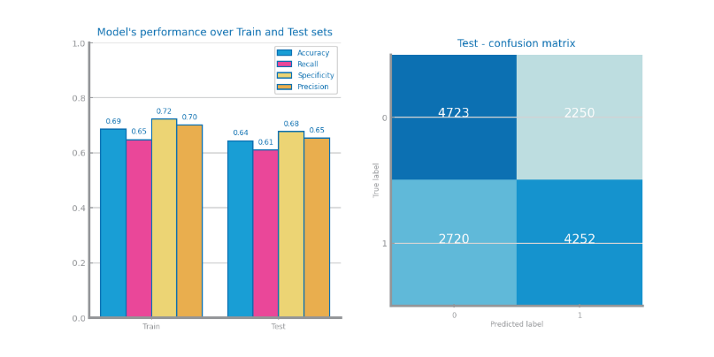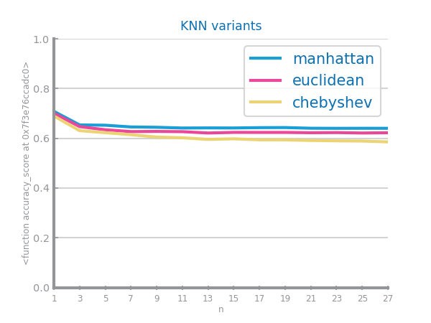

Figure 33 KNN different parameterizations comparison for dataset 2

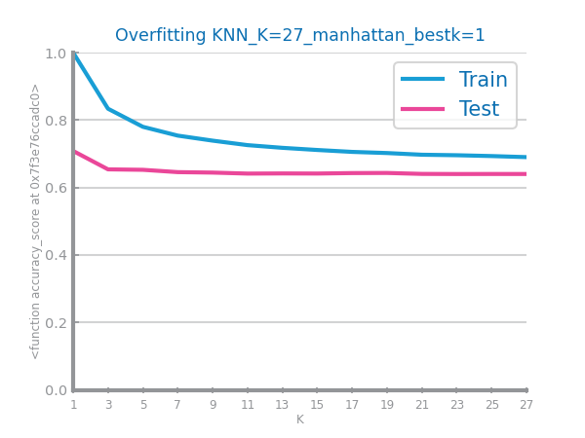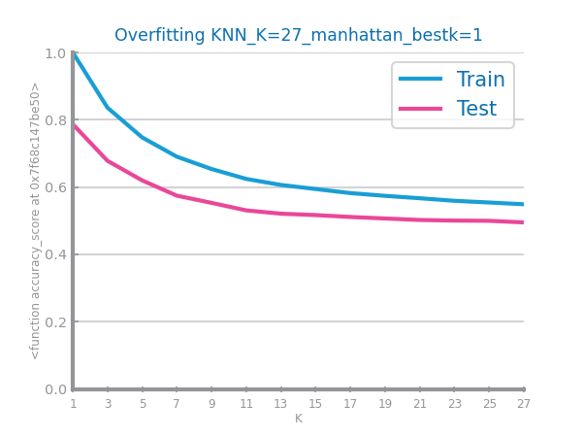

Figure 34 KNN overfitting analysis for dataset 1 (left) and dataset 2 (right)

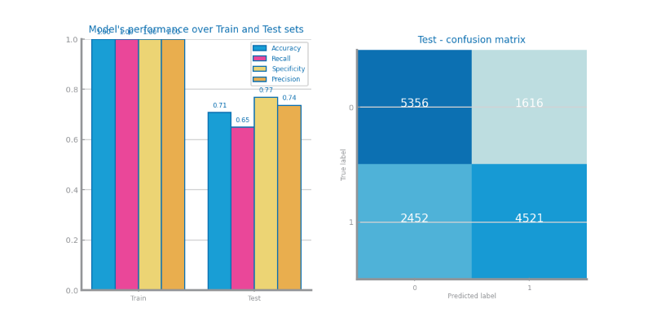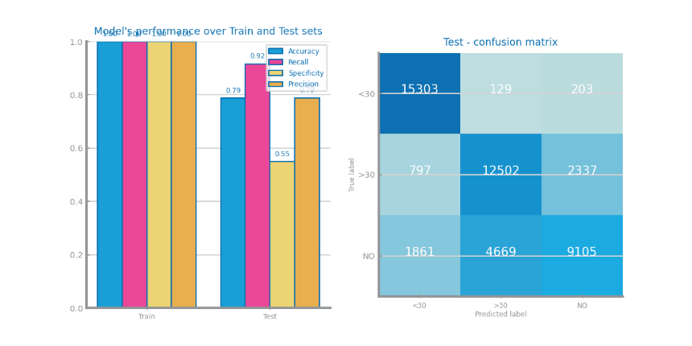

Figure 35 KNN best model results for dataset 1 (left) and dataset 2 (right)

## Decision Trees

The best model for dataset 1 was with entropy criteria, depth of 10 and impurity decrease of 0.00, it gave an accuracy of 0.50 this may happen because one three is not complex enough to classify the dataset this may be corrected by using a random forest for example. And for dataset 2 was with entropy criteria, depth of 25, impurity decrease of 0.00, and it gave an accuracy of 0.89 this is better than for dataset 1 because the dataset is simpler to classify. Despite decision trees being prone to overfitting this did not happen in this cases this is probably because we did not make tree deep enough for that to happen.

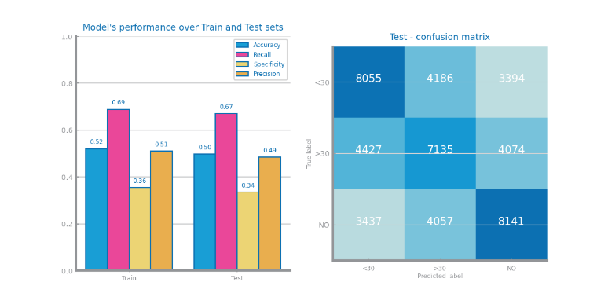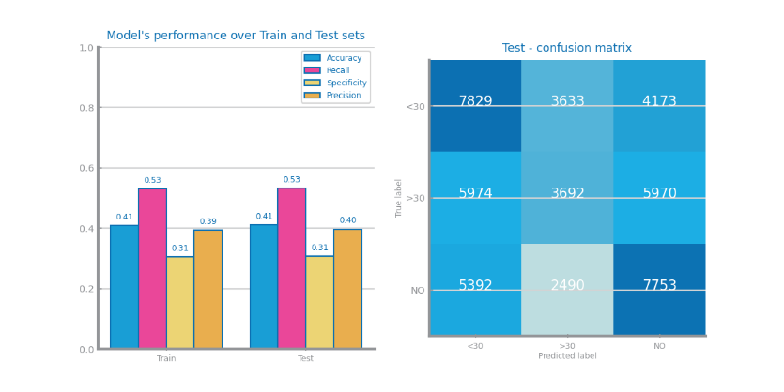

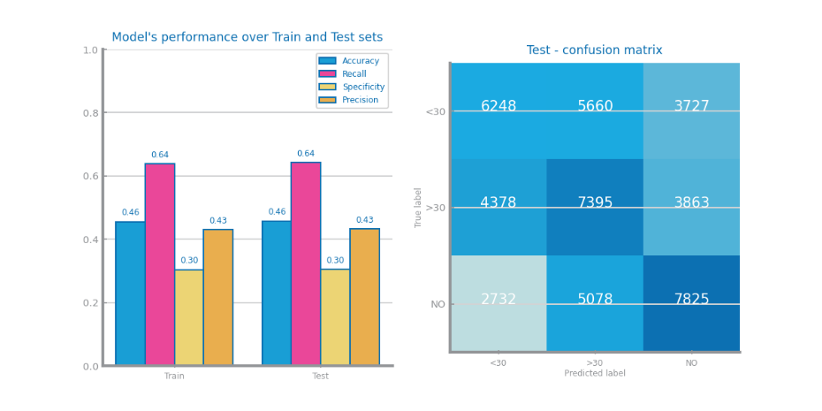

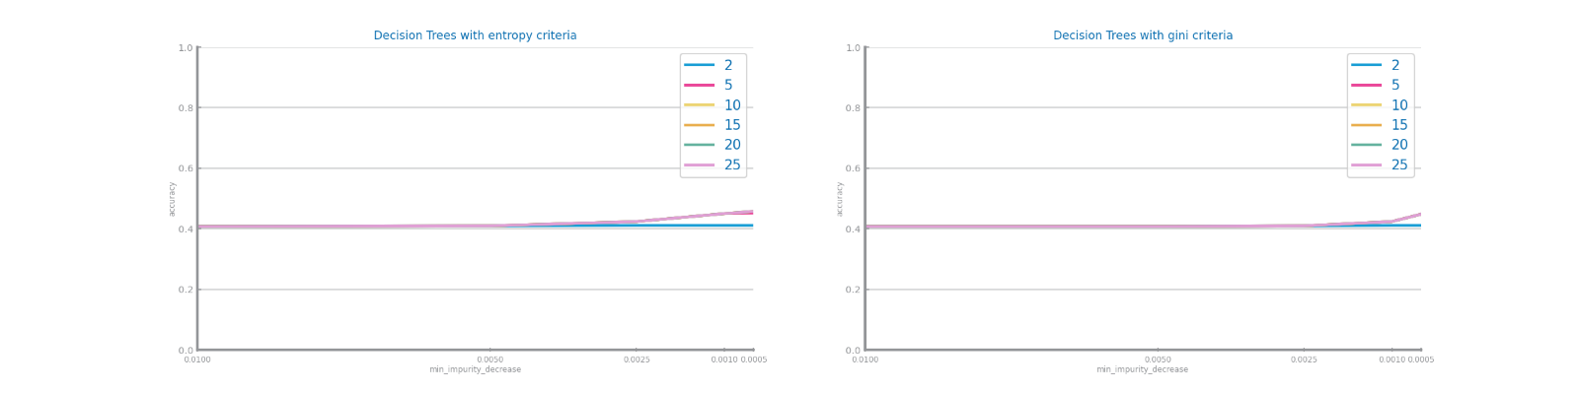

Figure 36 Decision Trees different parameterizations comparison for dataset 1

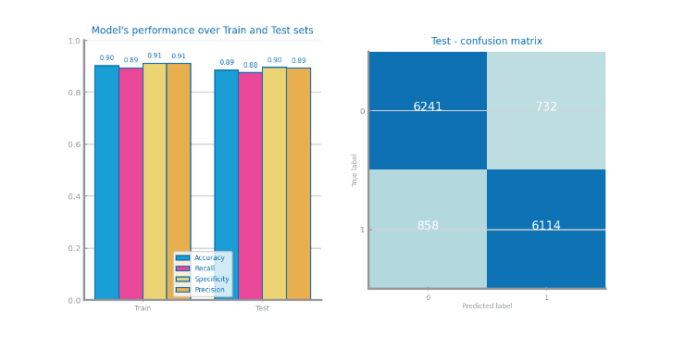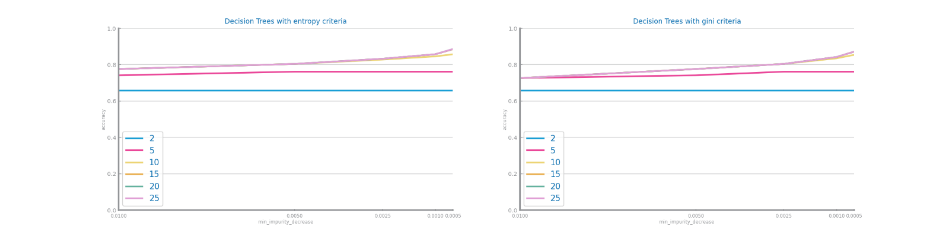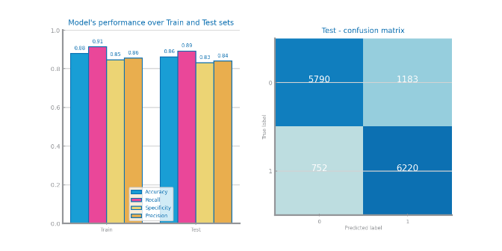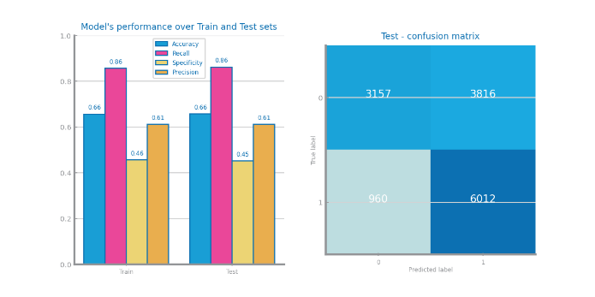

Figure 37 Decision Trees different parameterizations comparison for dataset 2

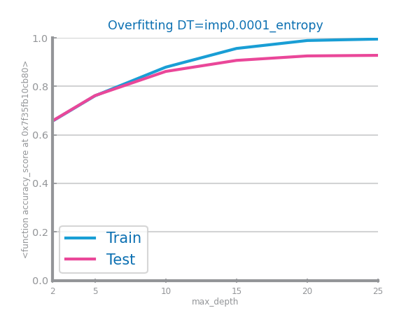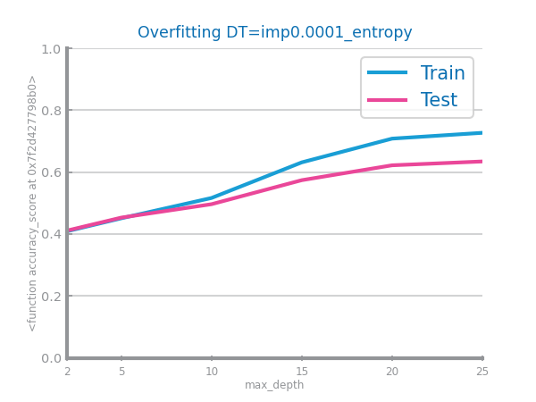

Figure 38 Decision Trees overfitting analysis for dataset 1 (left) and dataset 2 (right)

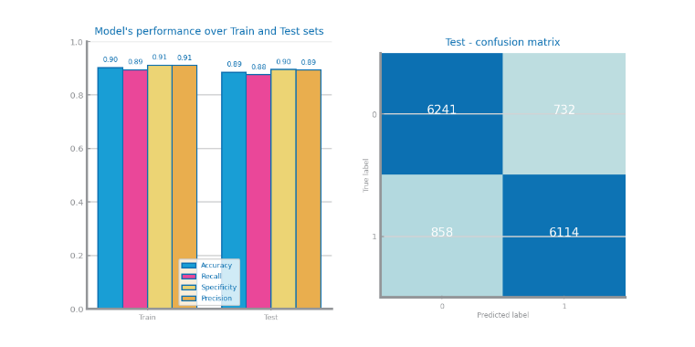



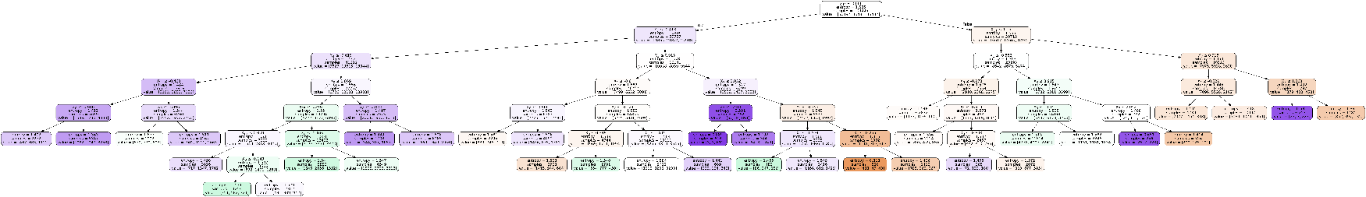Figure 39 Decision trees best model results for dataset 1 (left) and dataset 2 (right)

Figure 40 Best tree for dataset 1

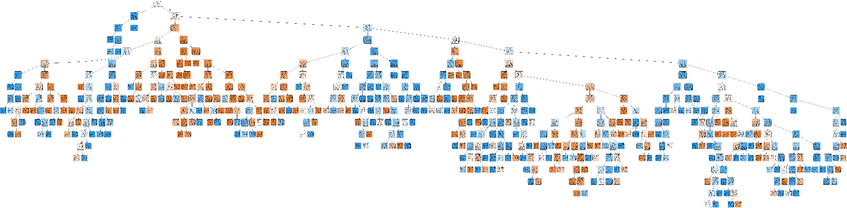

Figure 41 Best trees for dataset 2

## Random Forests

The best model for dataset 1 was depth of 25, 0.30 features and 400 estimators with an accuracy of 0.86. For dataset 2 was depth of 25, 0.70 features and 400 estimators with an accuracy of 0.95. In both datasets the results were significantly better because with random forests we are using a lot of decision trees and can learn more patterns of the datasets. This strategy also does not overfit when we use over 50 estimators because by using so many trees we correct the overfit that each of them have over their specific training data.

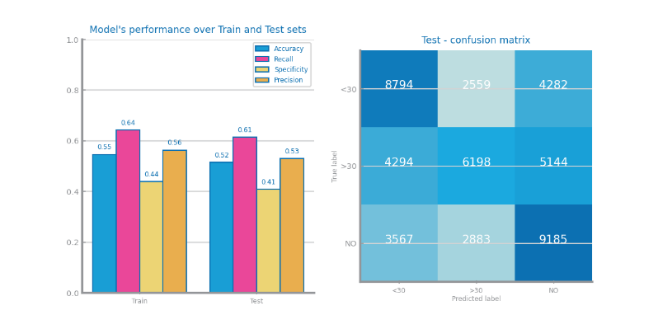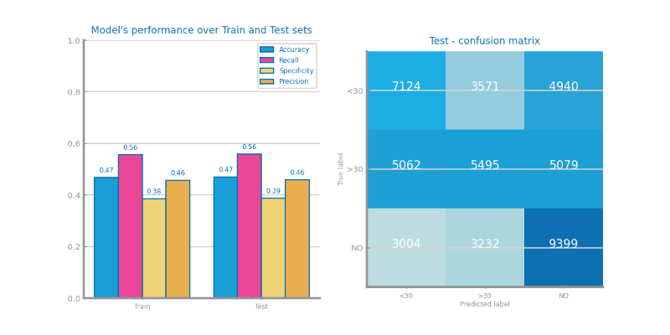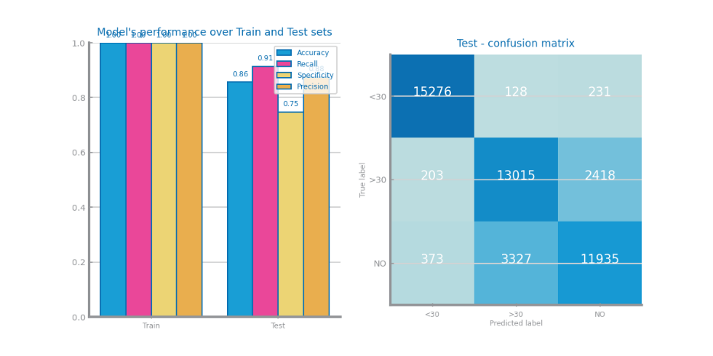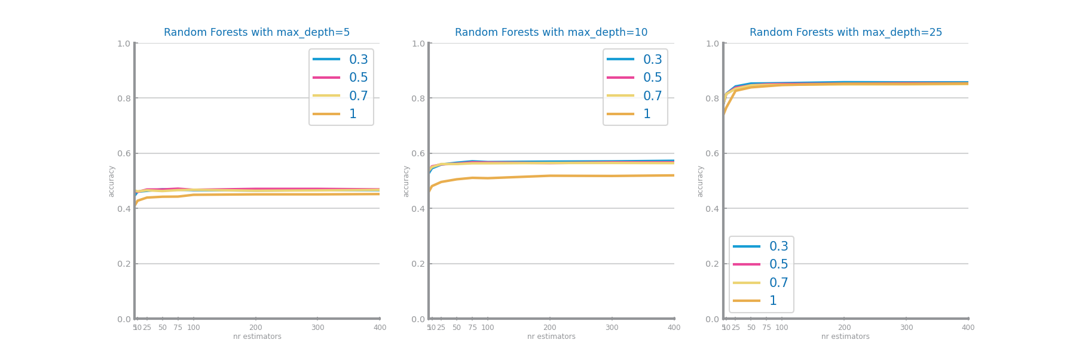

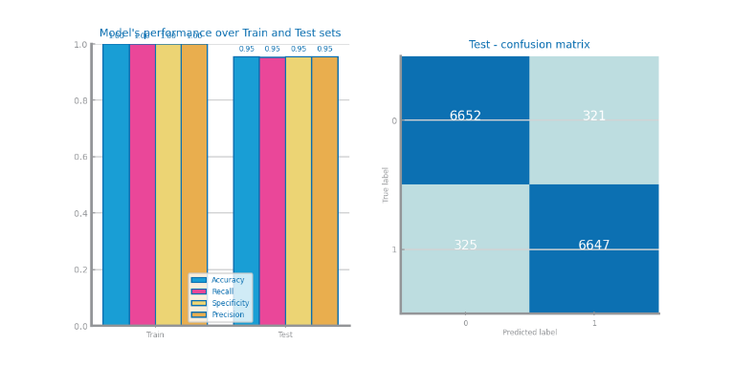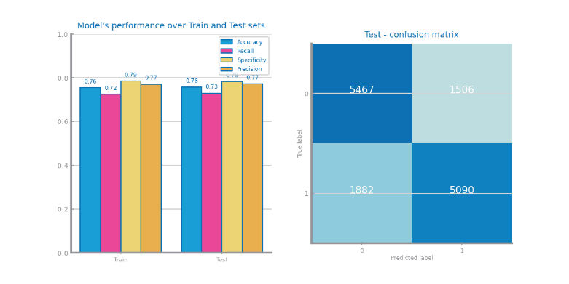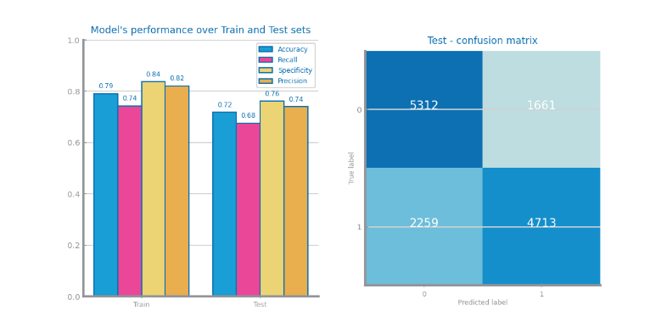Figure 42 Random Forests different parameterizations comparison for dataset 1

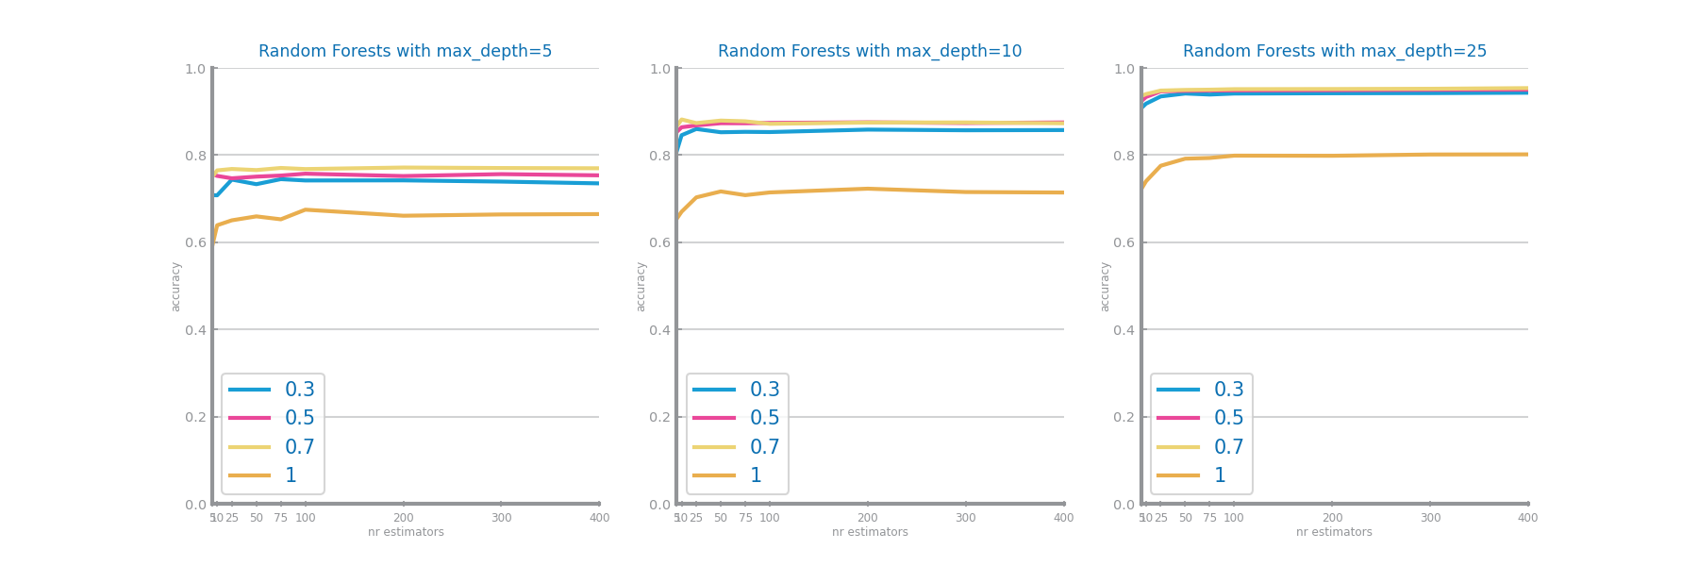

Figure 43 Random Forests different parameterizations comparison for dataset 2

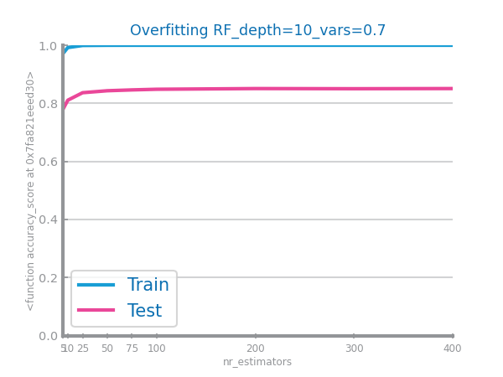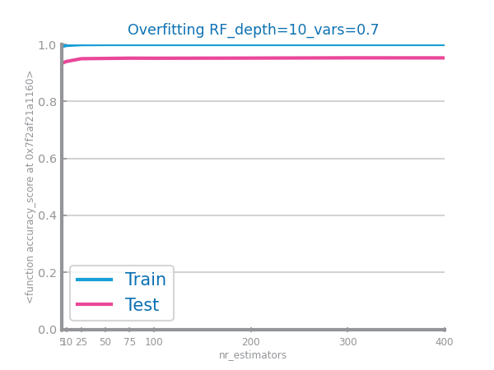

Figure 44 Random Forests overfitting analysis for dataset 1 (left) and dataset 2 (right)

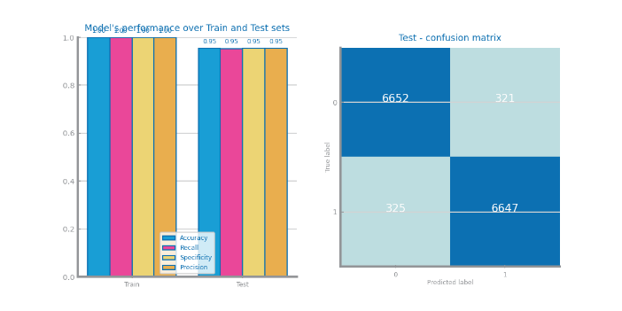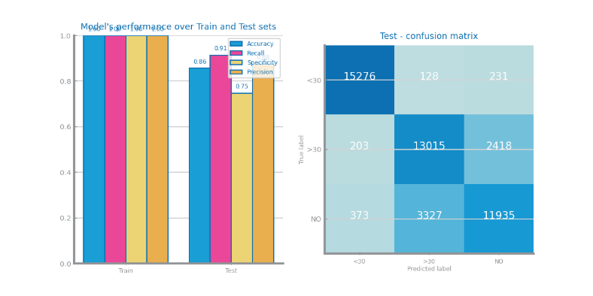

Figure 45 Random Forests best model results for dataset 1 (left) and dataset 2 (right)

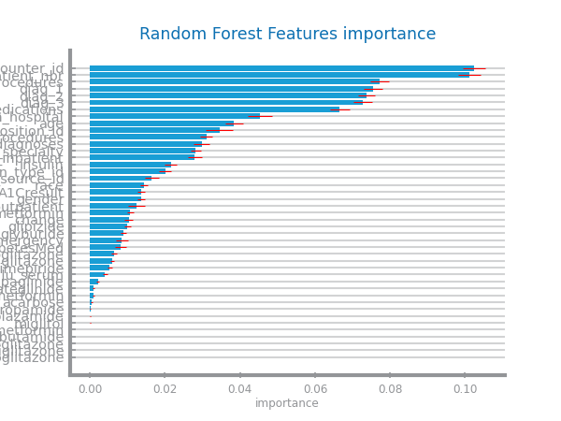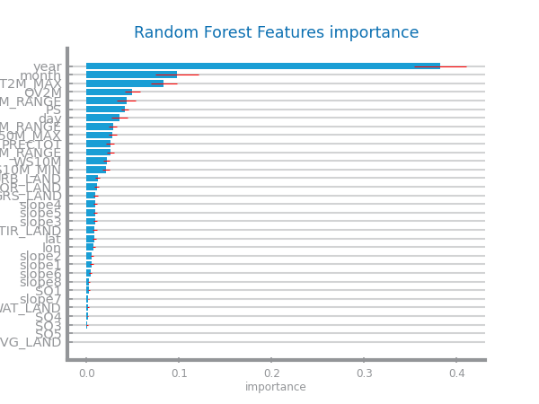

Figure 46 Random Forests variables importance for dataset 1 (left) and dataset 2 (right)

## Gradient Boosting

The best model for dataset 1 was depth of 25, learning rate of 0.5 and 50 estimators with an accuracy of 0.87. For dataset 2 was depth of 10, learning rate of 0.5 and 400 estimators with an accuracy of 0.87. In both datasets we got good results because with gradient boosting we are using a lot of weak learners to learn more patterns of the datasets, which in a lot of cases is better than having a single estimator. This strategy also does not overfit when we use over 25 estimators because by using so many estimators we correct the overfit that each of them might have.

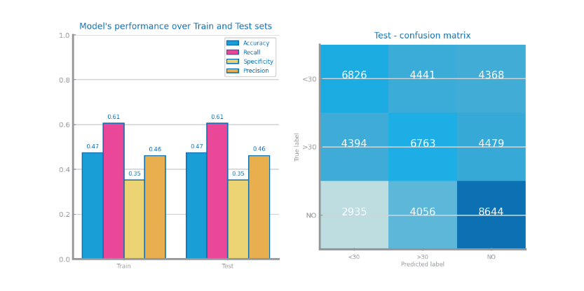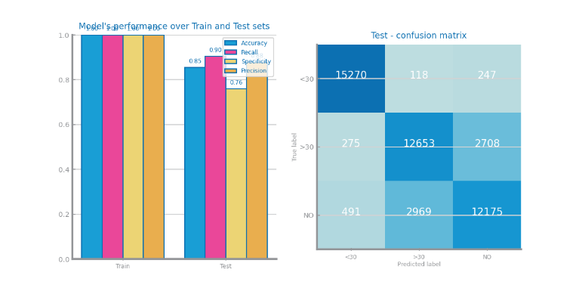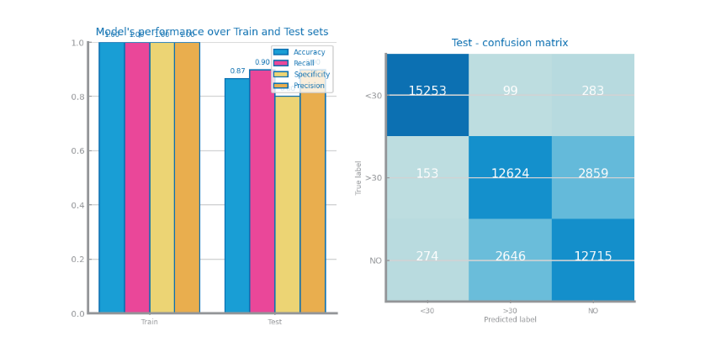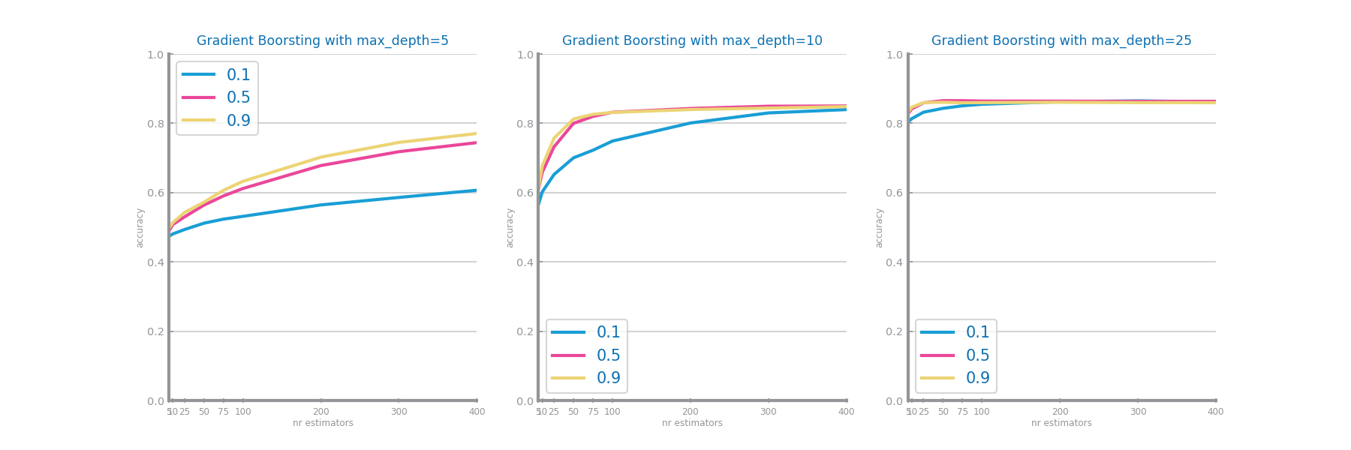

Figure 47 Gradient boosting different parameterizations comparison for dataset 1

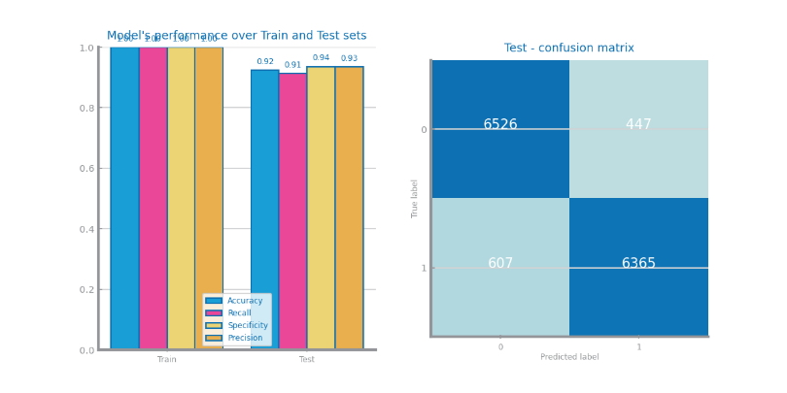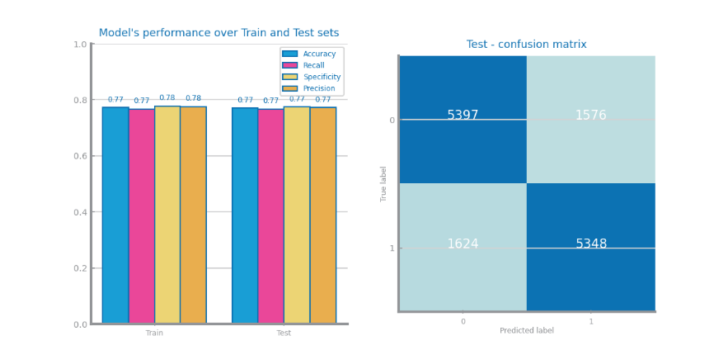

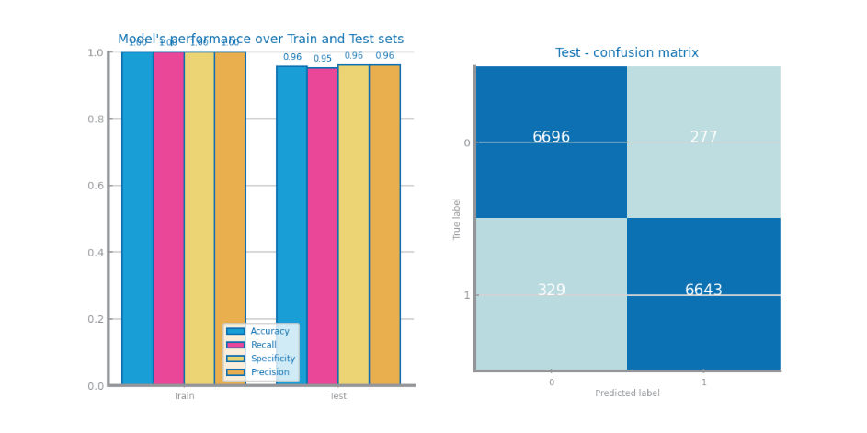

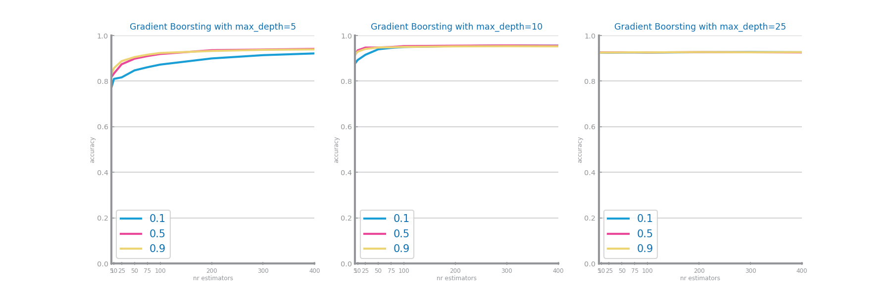

Figure 48 Gradient boosting different parameterizations comparison for dataset 2

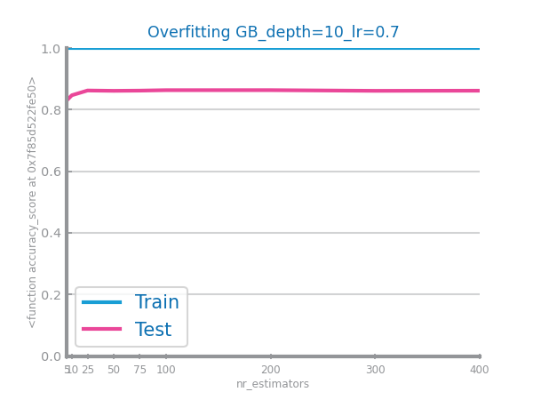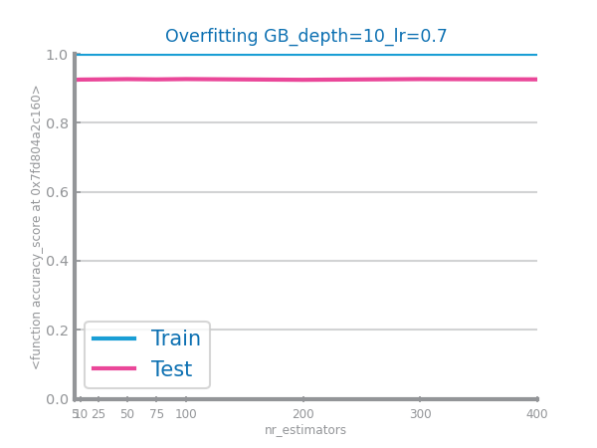

Figure 49 Gradient boosting overfitting analysis for dataset 1 (left) and dataset 2 (right)

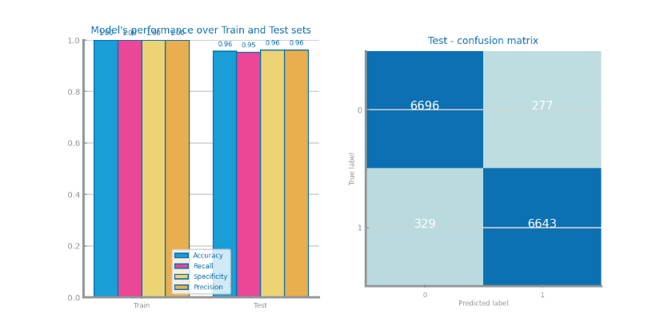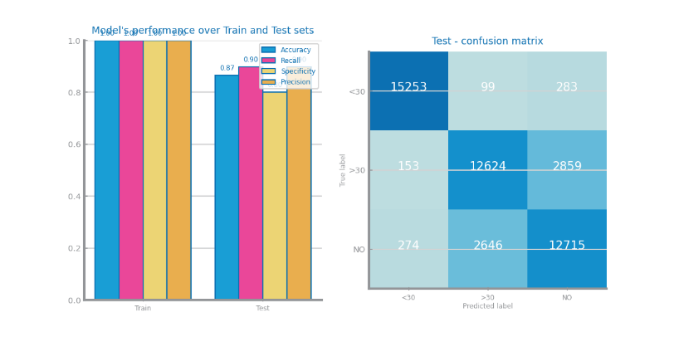

Figure 50 Gradient boosting best model results for dataset 1 (left) and dataset 2 (right)

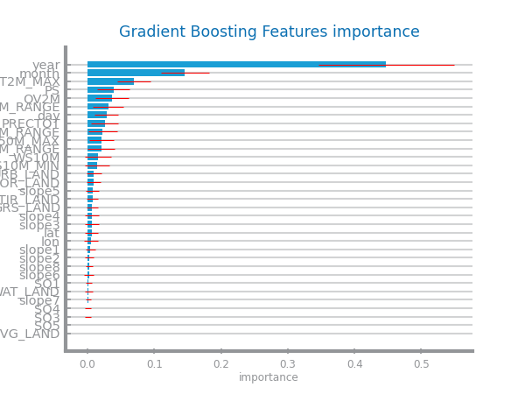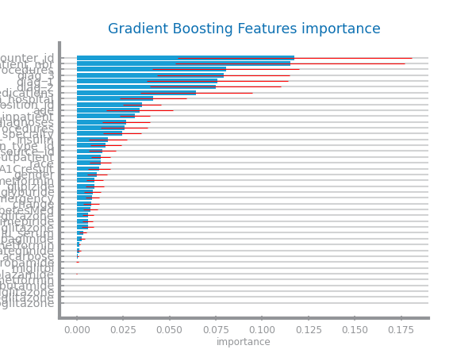

Figure 51 Gradient boosting variables importance for dataset 1 (left) and dataset 2 (right)

## Multi-Layer Perceptrons

The best model for dataset 1 was adaptive learning rate type, learning rate of 0.1 and 750 max iterations with an accuracy of 0.55. For dataset 2 was adaptive learning rate type, learning rate of 0.1 and 750 max iterations with an accuracy of 0.86. In dataset 1 the results were not great because this may happen because the model did not have sufficient hidden layers and could not learn the patterns in the data. For dataset 2 we obtained good results this difference between dataset 1 and 2 may happen because dataset 2 has less complexity. This strategy also does not overfit this is probably because an adaptive learning rate prevents overfitting.

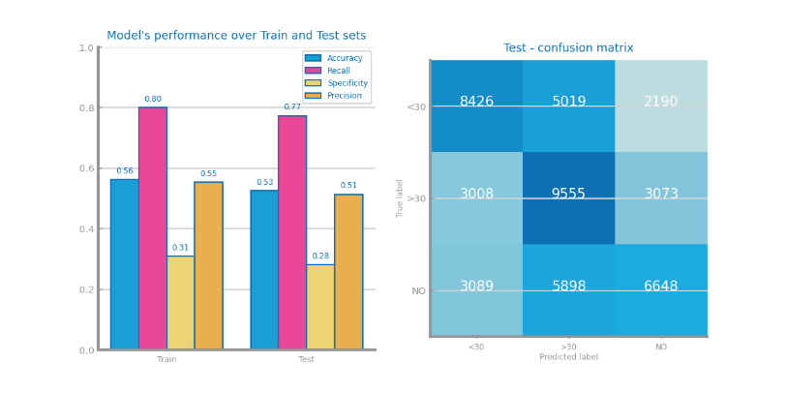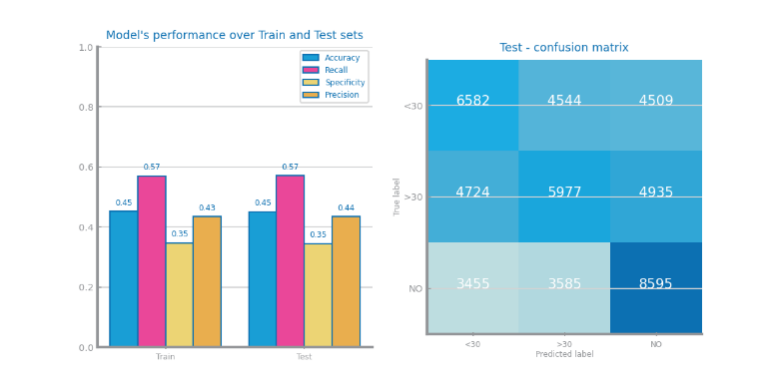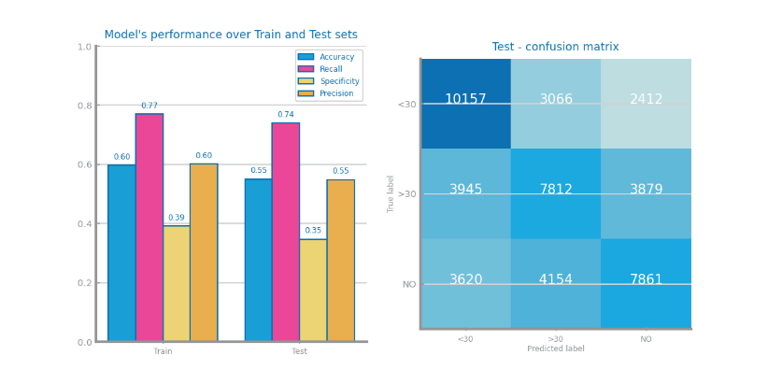

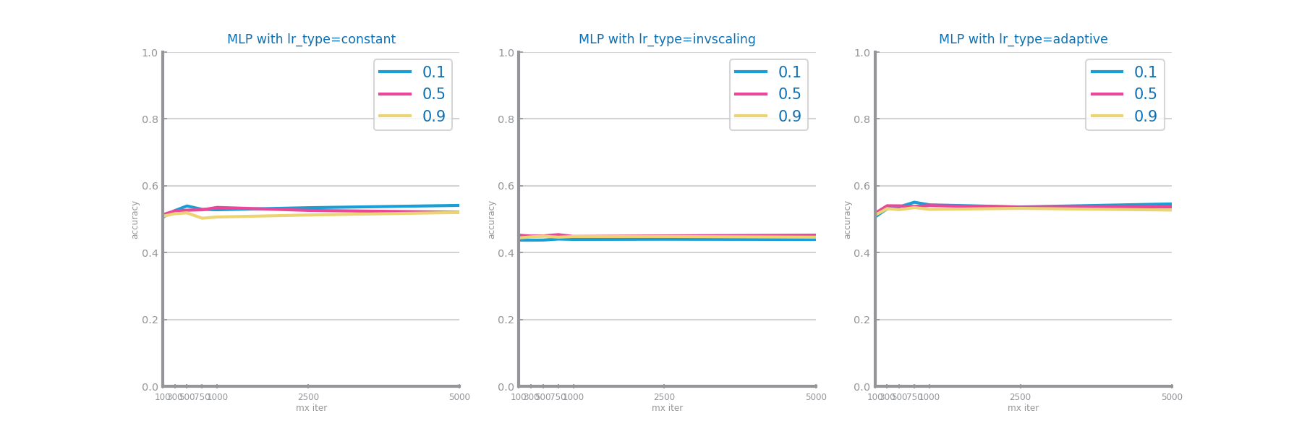

Figure 52 MLP different parameterizations comparison for dataset 1

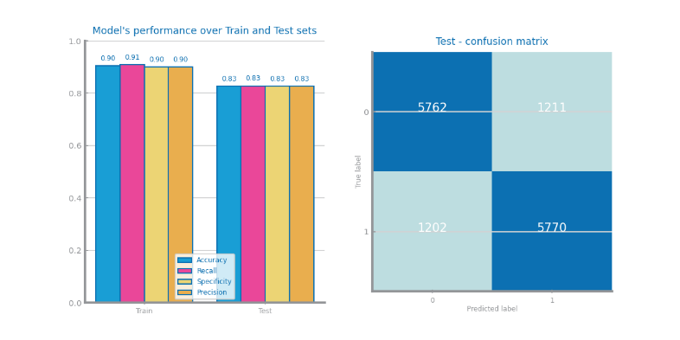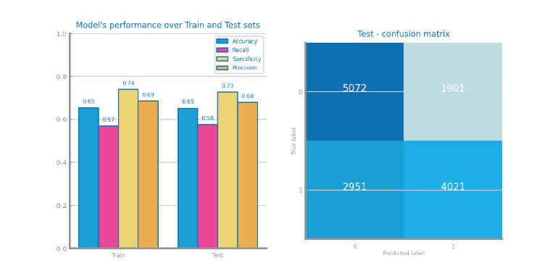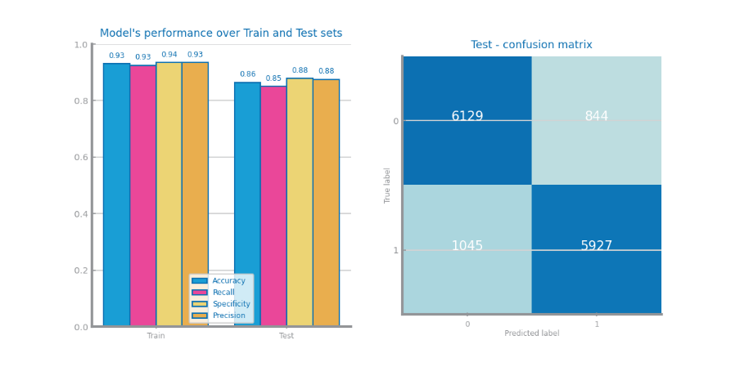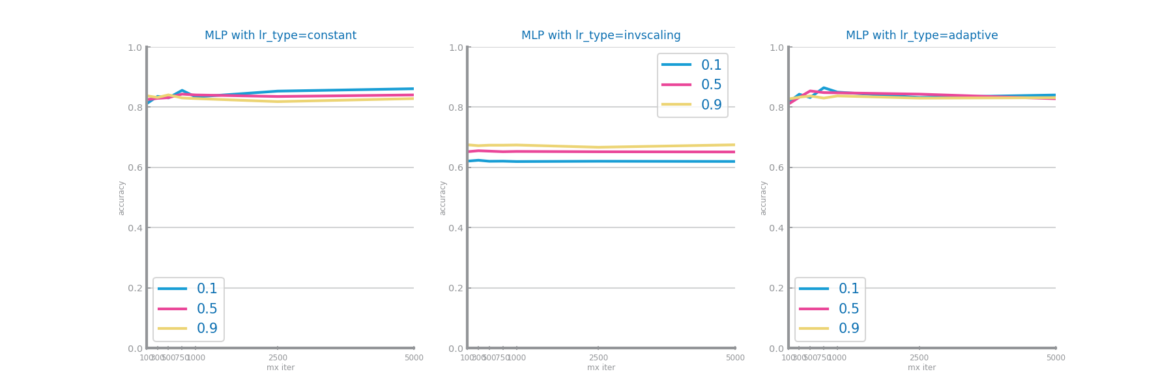

Figure 53 MLP different parameterizations comparison for dataset 2

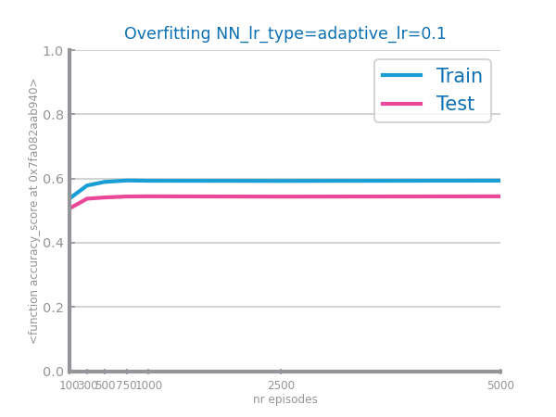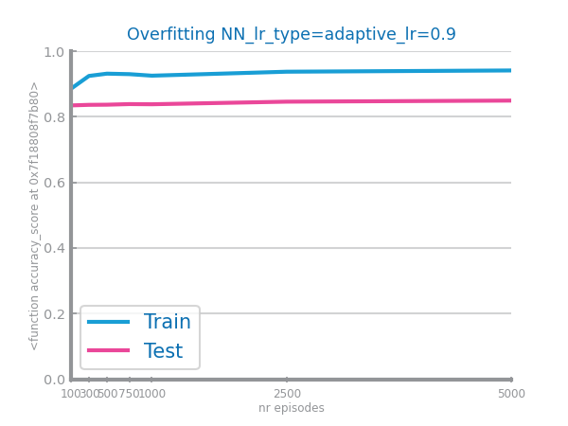

Figure 54 MLP overfitting analysis for dataset 1 (left) and dataset 2 (right)

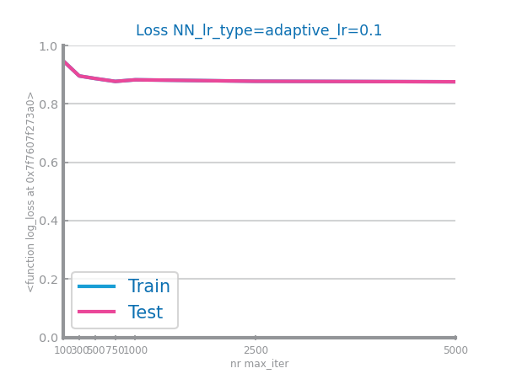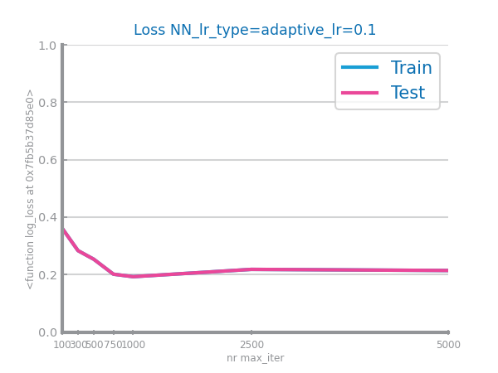

Figure 55 Loss curves analysis for dataset 1 (left) and dataset 2 (right)

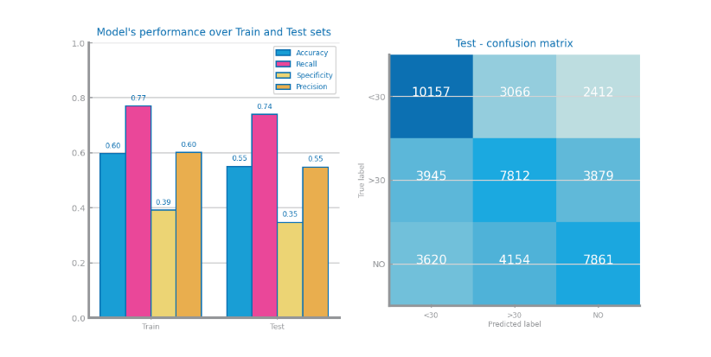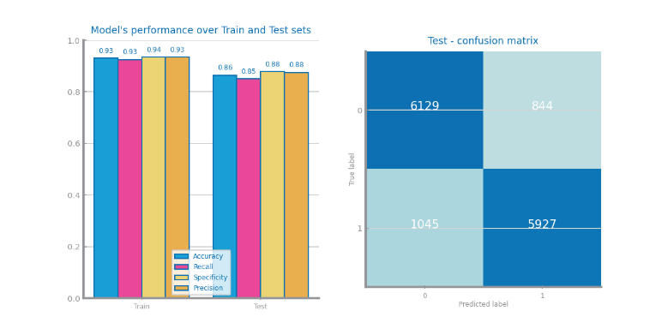

Figure 56 MLP best model results for dataset 1 (left) and dataset 2 (right)

# Critical Analysis

The accuracies for each model were for dataset 1: Naïve Bayes Bernoulli – 0.42, KNN – 0.79, Decision Tree – 0.50, Random Forest – 0.86, Gradient Boosting – 0.87, MLP – 0.55.

The accuracies for each model were for dataset 1: Naïve Bayes Gaussian – 0.59, KNN – 0.71, Decision Tree - 0.89, Random Forest – 0.95, Gradient Boosting – 0.96, MLP – 0.86.

For both datasets the best models were Random Forest and Gradient Boosting this shows that individual models like the NB, KNN, DT and MLP underperform in relation to models that are a combination of estimators or weak learners. This is probably because the data (especially dataset 1 which is a ternary classification problem) is too complex and has many pattern for a single good estimator.

For these two best models in dataset 1 almost all variables were important this is probably the reason why only models that are a combination of estimators or weak learners performed well on this dataset.

In dataset 1 the year variable was a lot more important than the other ones this is why single estimators like the MLP and Decision Tree performed well on this dataset however the Random Forest and Gradient Boosting were still better.

The Random Forest and Gradient Boosting seem good enough for the tasks at hand because the other results besides accuracy were also pretty good. This is specially the case for dataset 2 with 96% accuracy for dataset 1 we also think these two models are good enough with 86% accuracy.

Time Series Forecasting

# Data Profiling

## Data Granularity

For dataset 1, the most atomic granularity is the hourly aggregation, and the other two granularities are daily and weekly.

For dataset 2, the most atomic granularity is the daily aggregation, and the other two granularities are monthly and quarterly.

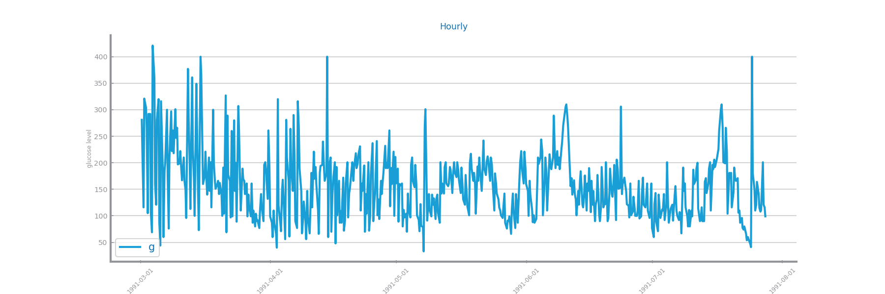

Figure 57 Time series 1 at the most granular detail

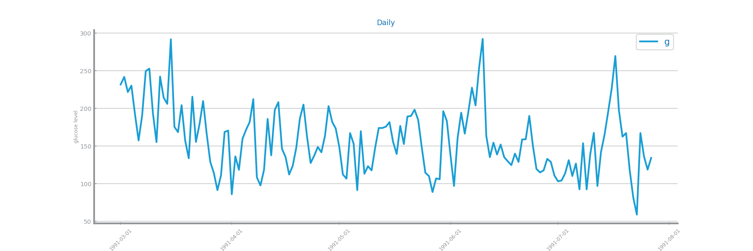

Figure 58 Time series 1 at the second chosen granularity

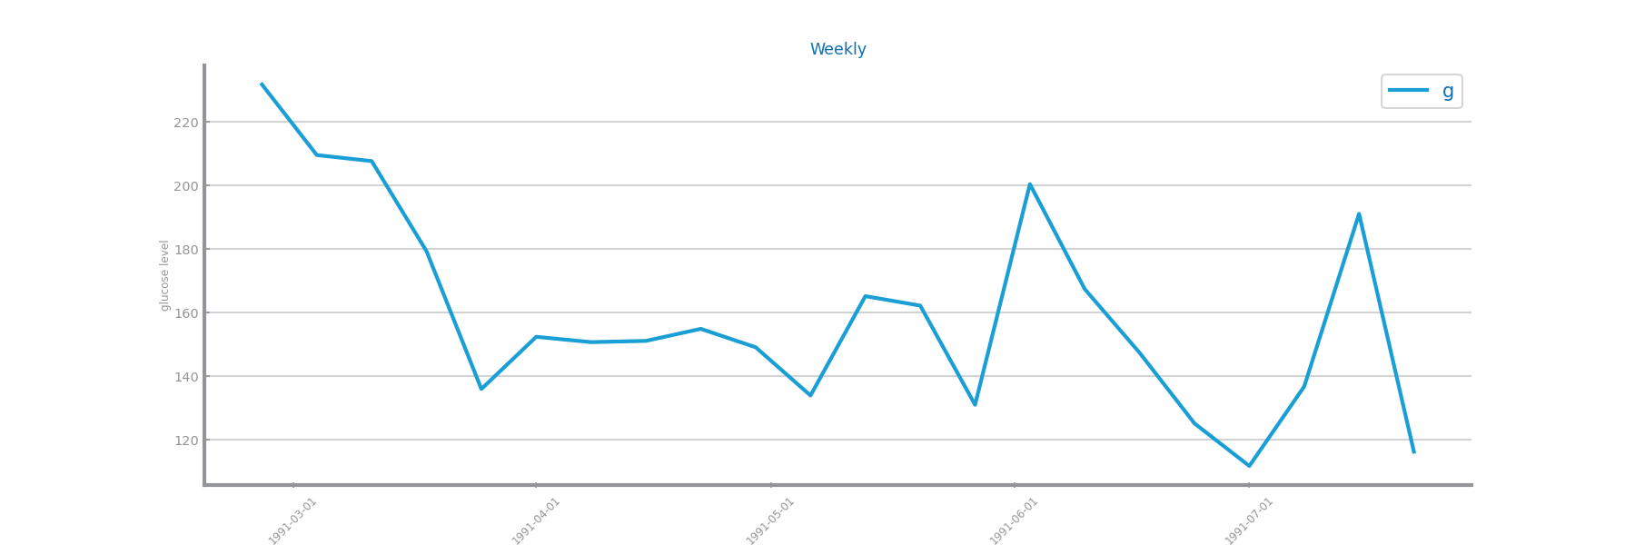

Figure 59 Time series 1 at the third chosen granularity

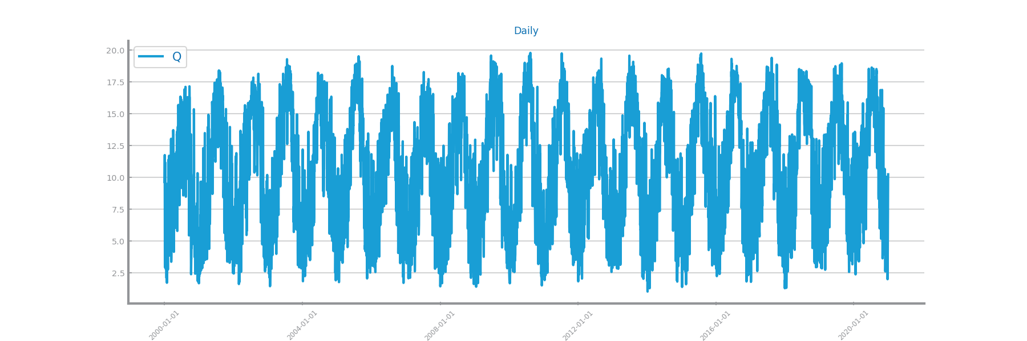

Figure 60 Time series 2 at the most granular detail

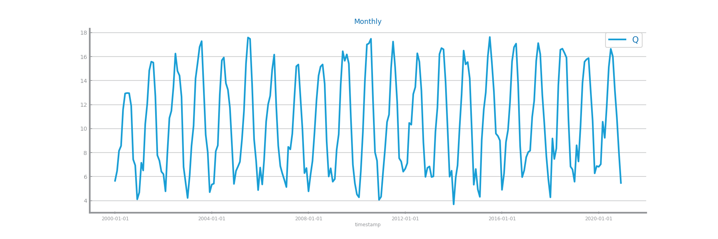

Figure 61 Time series 2 at the second chosen granularity

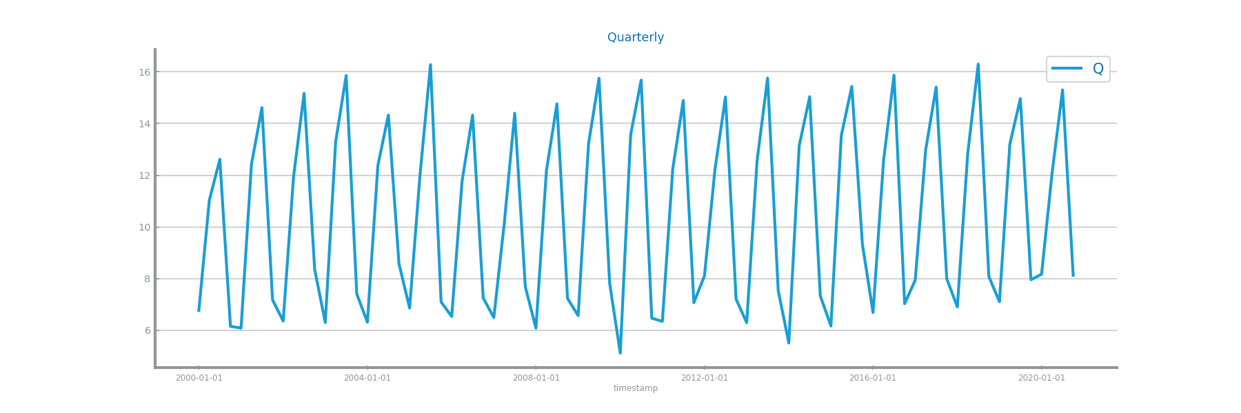

Figure 62 Time series 2 at the third chosen granularity

## Data Distribution and Stationarity

In dataset 1 the data does not follow a normal distribution it seems that follows a non symmetric distribution. In dataset 2 QV2M follows a bimodal distribution. For the stationarity study we used the most atomic aggregation for both datasets and we concluded that the mean of the data for dataset 2 is stationary and for dataset 1 it is not.

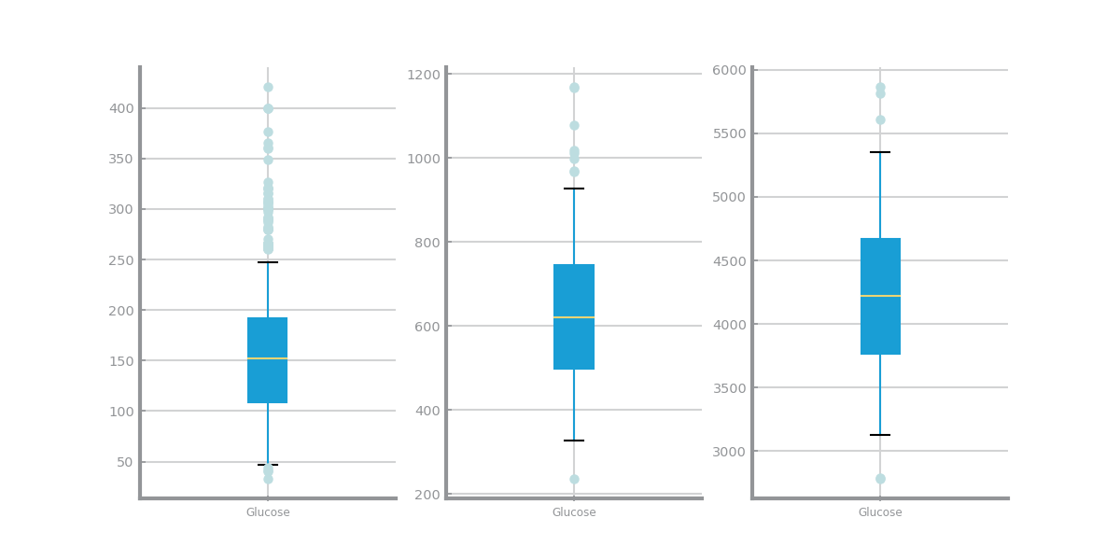

Figure 63 Boxplot(s) for time series 1

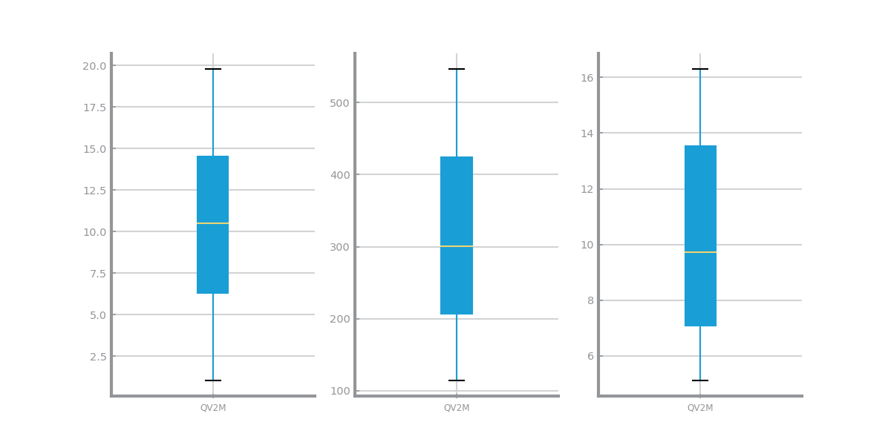

Figure 64 Boxplot(s) for time series 2

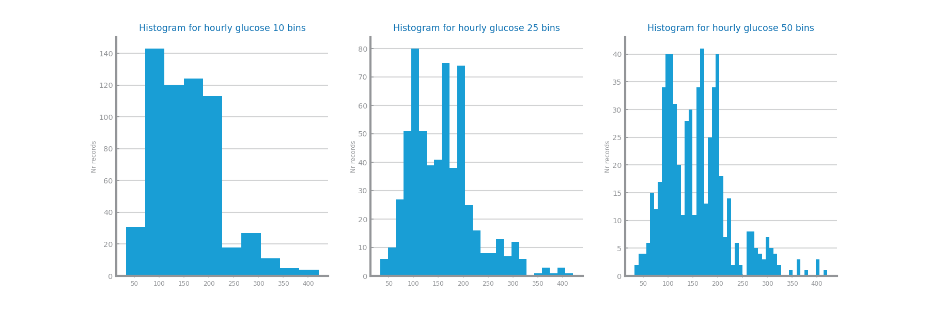

Figure 65 Histogram(s) for time series 1

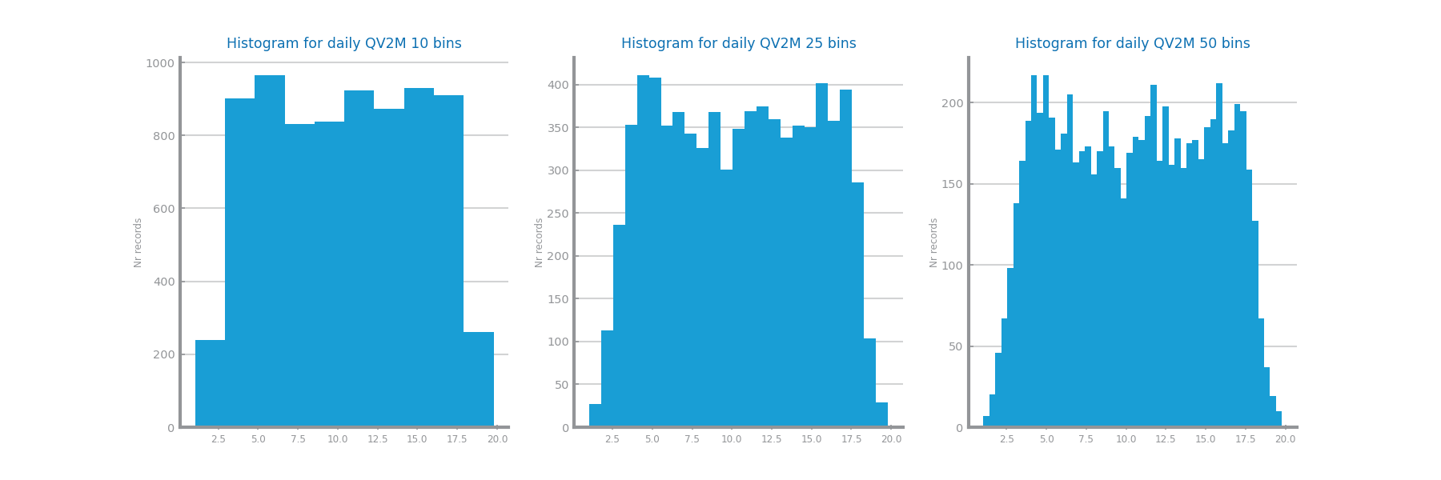

Figure 66 Histogram(s) for time series 2

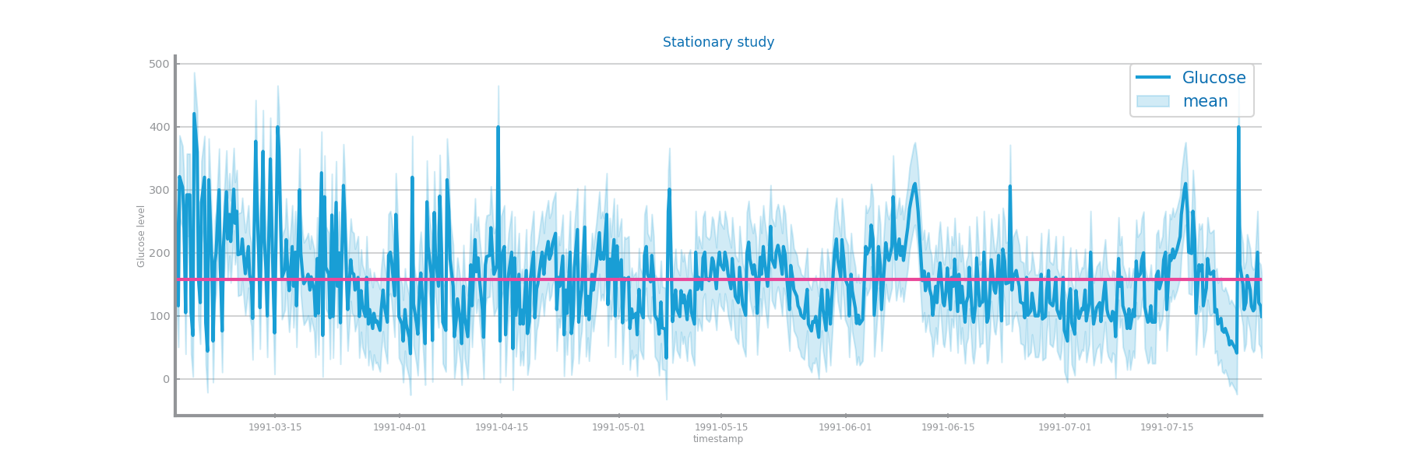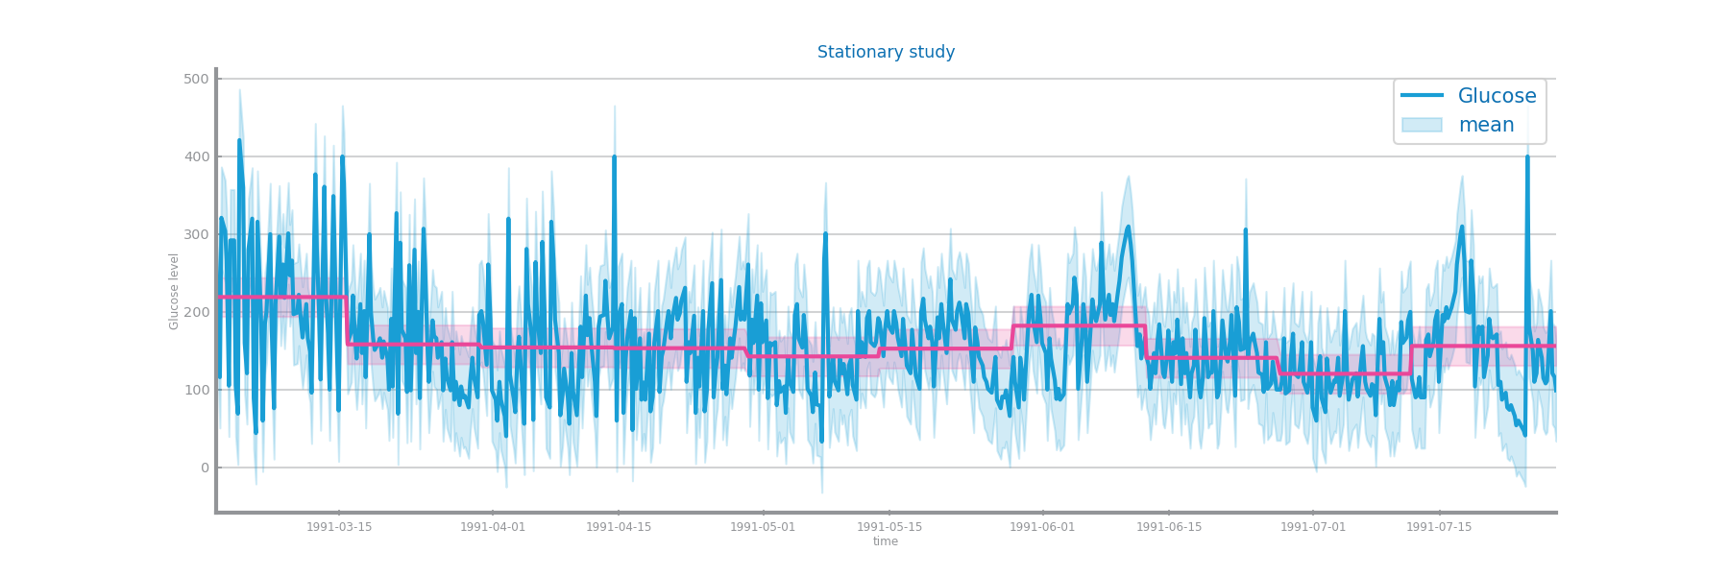

Figure 67 Stationarity study for time series 1

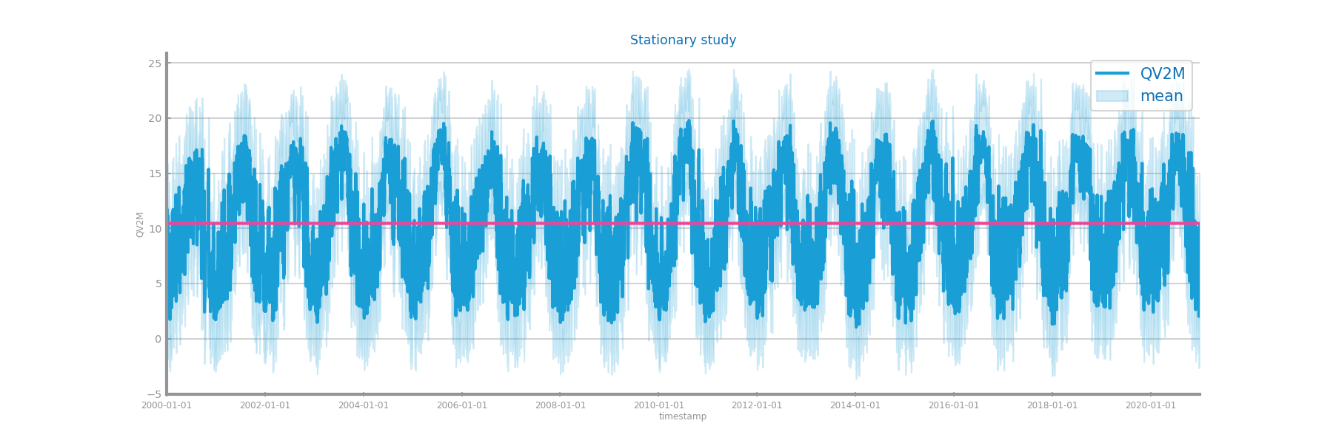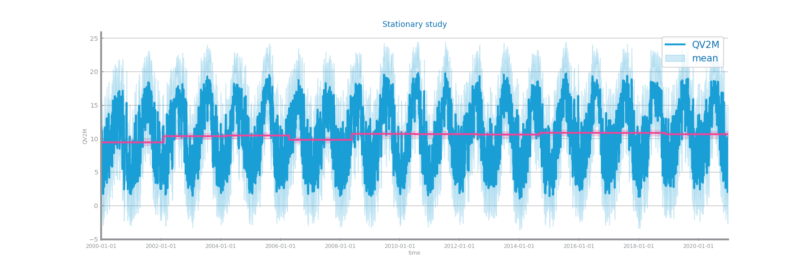

Figure 68 Stationarity study for time series 2

# Data Transformation

## Aggregation

In dataset 1 we applied the hourly, daily and weekly aggregations and applied the persistence model.

In dataset 2 we applied the daily, monthly and quarterly aggregations and also applied the persistence model.

However we can’t conclude anything because the persistence model is not the most adequate model.

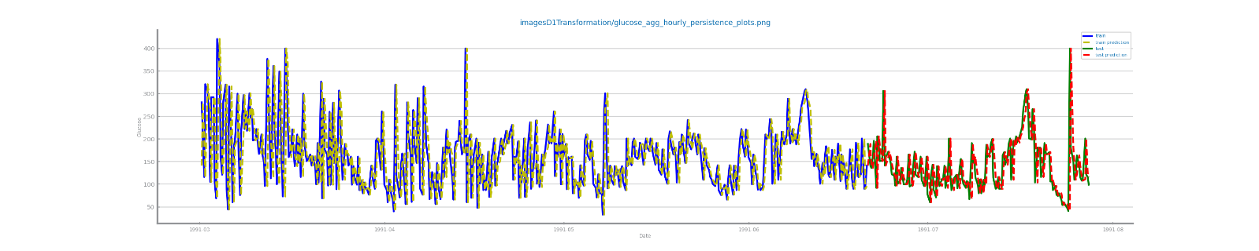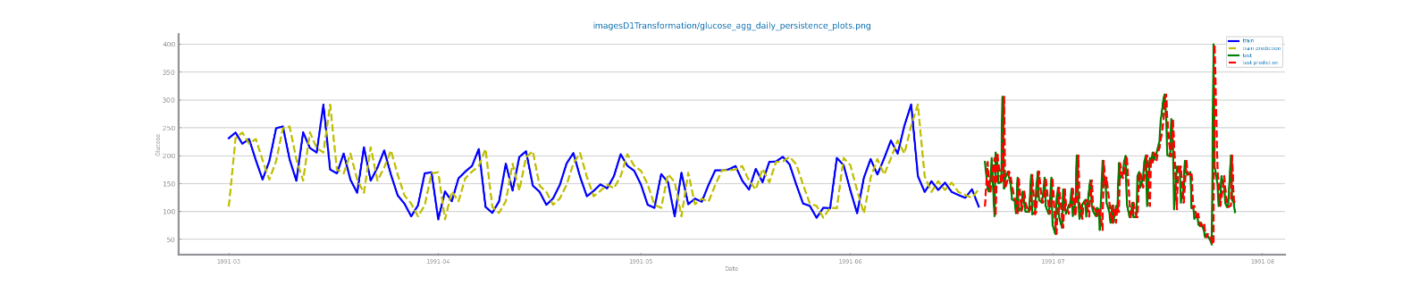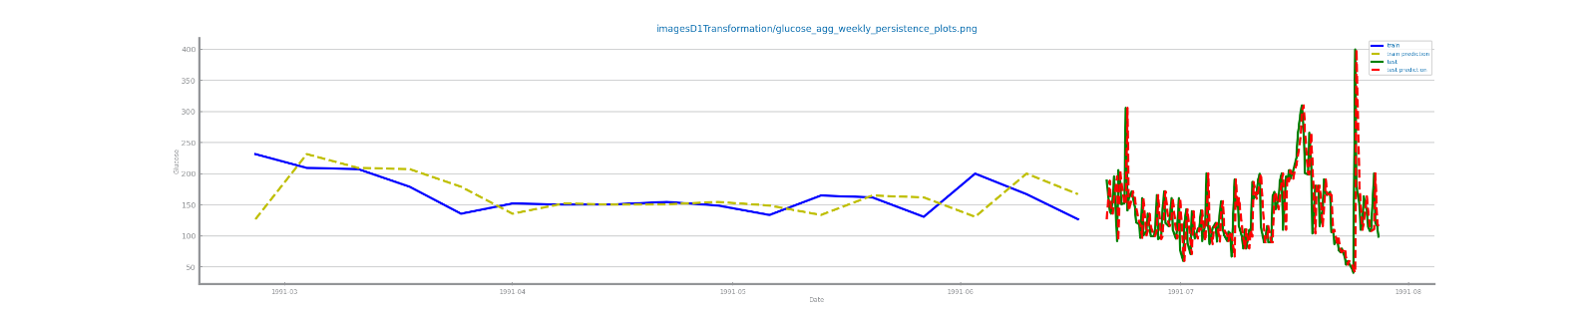

Figure 69 Forecasting plots after different aggregations on time series 1

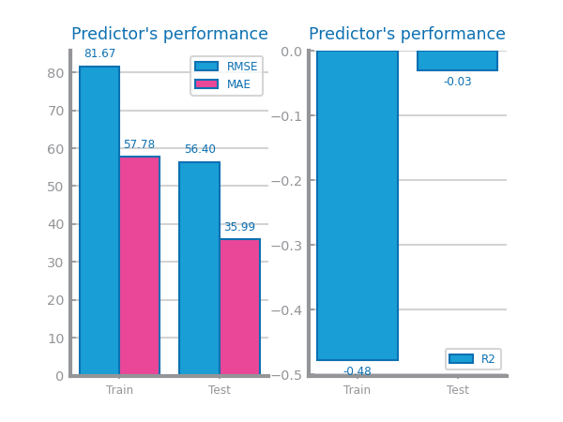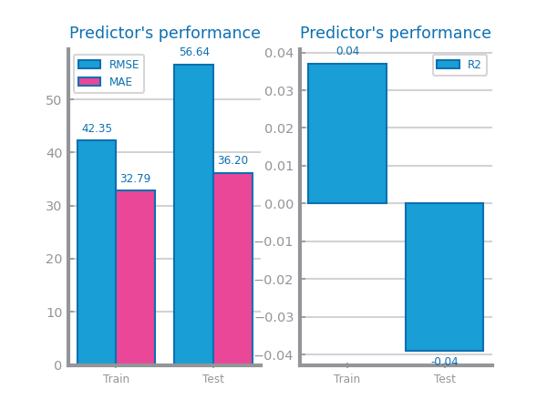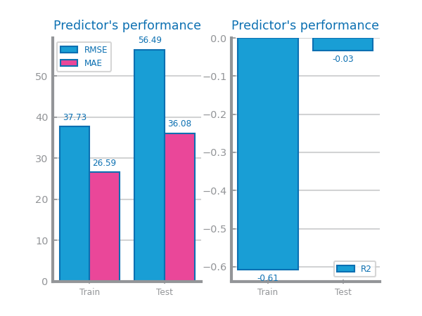

Figure 70 Forecasting results after different aggregations on time series 1

Figure 71 Forecasting plots after different aggregations on time series 2

Figure 72 Forecasting results after different aggregations on time series 2

## Smoothing

In dataset 1 we applied the 13, 50 and 100 window size for smoothing.

In dataset 2 we applied the 10, 50 and 100 window size for smoothing.

Then for the results we applied the persistence model but we can’t conclude anything because the persistence model is not the most adequate model.

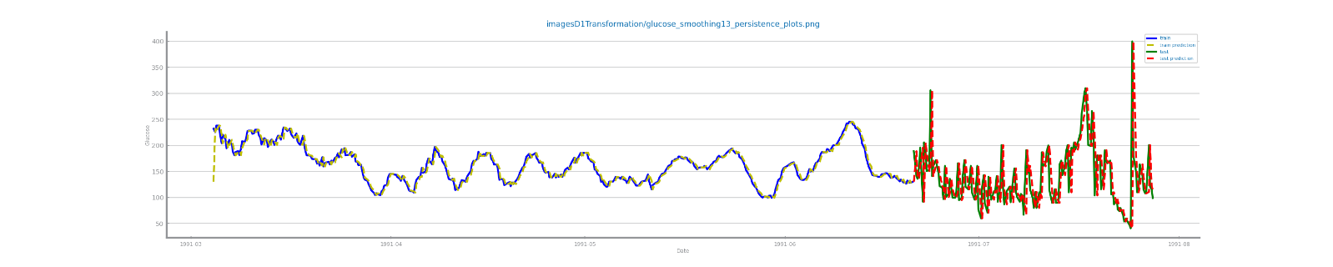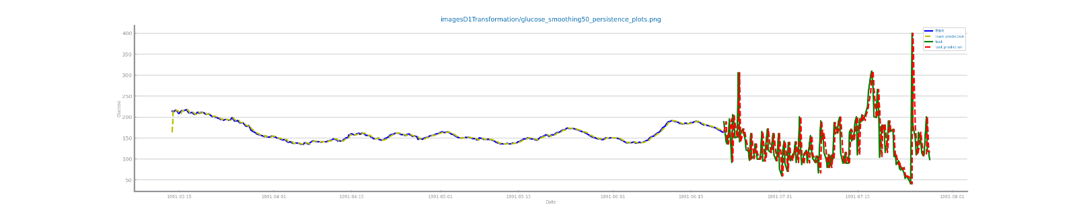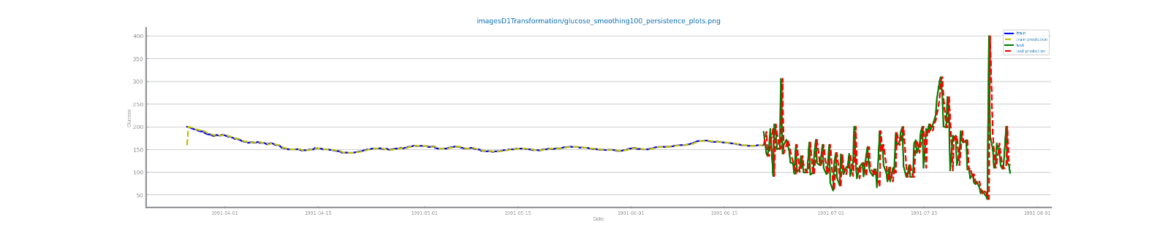

Figure 73 Forecasting plots after different smoothing parameterizations on time series 1

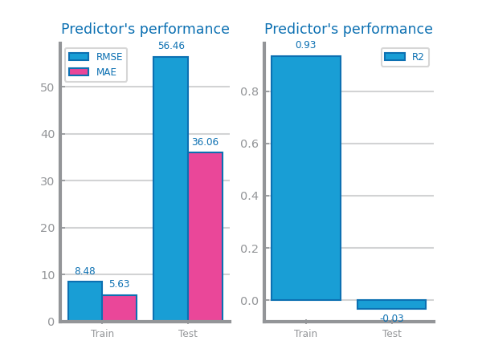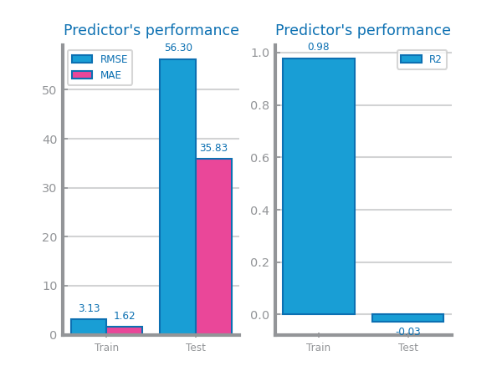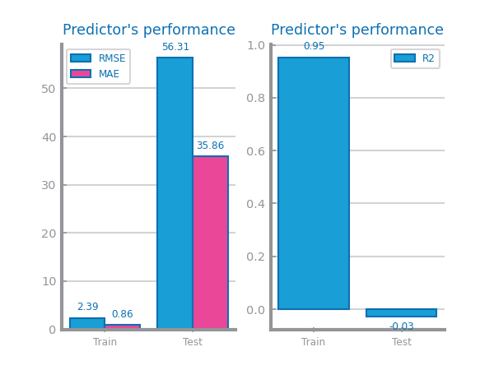

Figure 74 Forecasting results after different smoothing parameterizations on time series 1

Figure 75 Forecasting plots after different smoothing parameterizations on time series 2

Figure 76 Forecasting results after different smoothing parameterizations on time series 2

## Differentiation

We applied 1 and 2 differentiations to both datasets and applied the persistence model for the results however we can’t conclude anything because it is not the most adequate model.

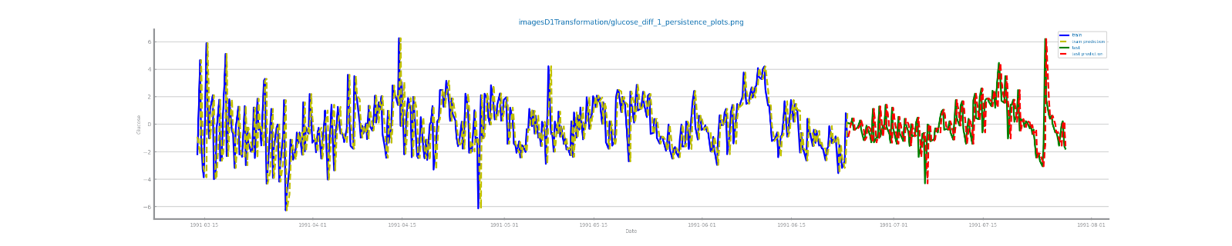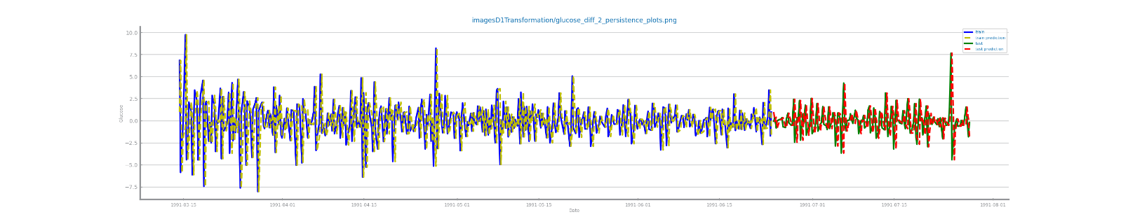

Figure 77 Forecasting plots after first and second differentiation of time series 1

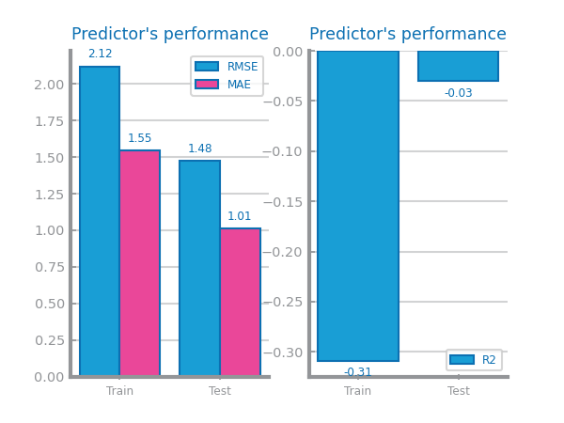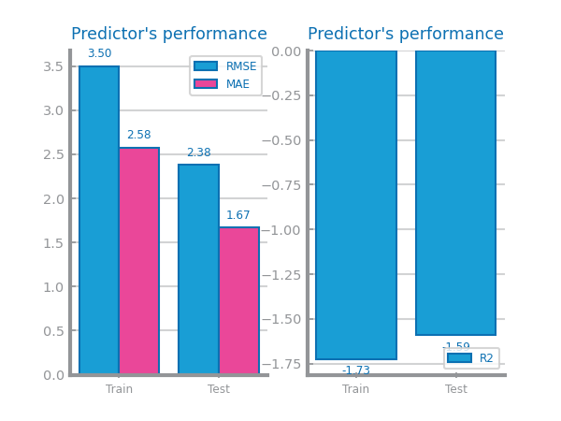

Figure 78 Forecasting results after first and second differentiation of time series 1

Figure 79 Forecasting plots after first and second differentiation of time series 2

Figure 80 Forecasting results after first and second differentiation of time series 2

# Models’ Evaluation

In both time series we dropped all variables that were not the target variable so the datasets became univariate and used the most atomic granularity for every model.

## Simple Average Model

The R2 score for time series 1 was -0.19 and for time series 2 was -0.01.

The results acquired with this model are not good since the models predicts the values just with the average value.

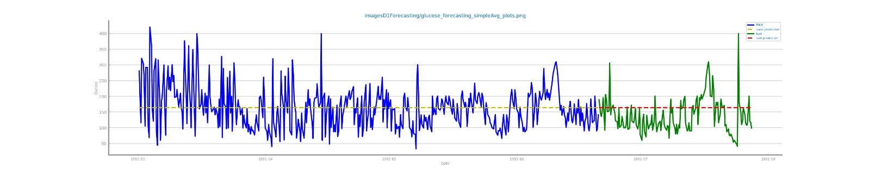

Figure 81 Forecasting plots obtained with Simple Average model over time series 1

Figure 82 Forecasting plots obtained with Simple Average model over time series 2

## Persistence Model

The R2 score for time series 1 was -0.03 and for time series 2 was 0.80.

The time series 2 had better results in relation to time series 1 because is a periodic time series.

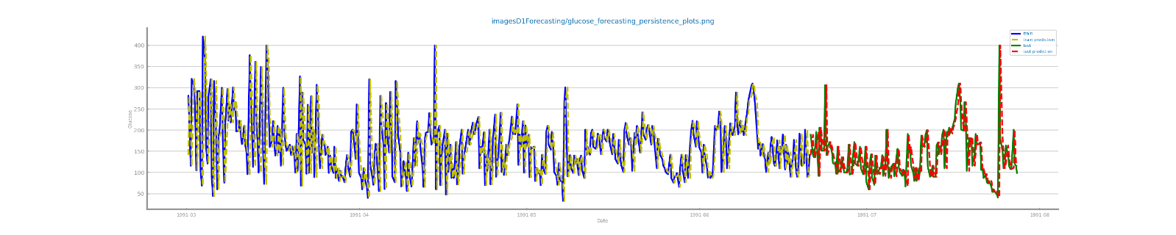

Figure 83 Forecasting plots obtained with Persistence model over time series 1

Figure 84 Forecasting plots obtained with Persistence model over time series 2

## Rolling Mean Model

We used three different window sizes (2, 5, 10) and in both datasets the smallest window size performed better this happens because when we rise the window size we are smoothing out the fluctuations of the time series in our predictions so the result will not be as high.

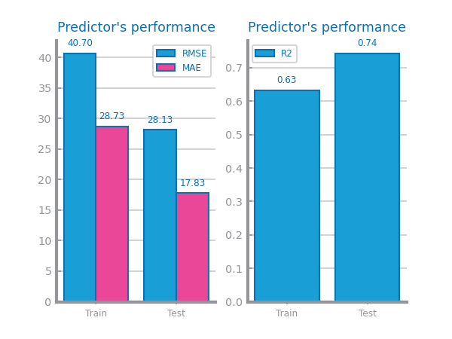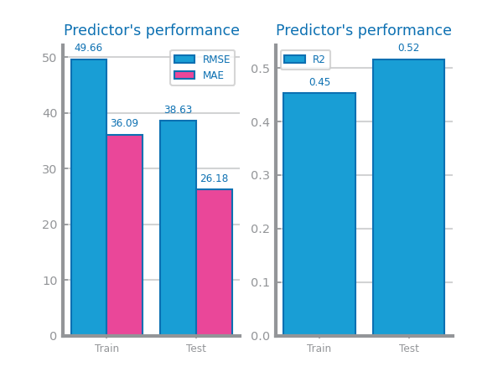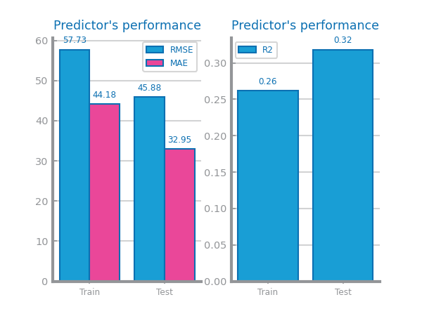

Figure 85 Forecasting study over different parameterizations of the rolling mean algorithm over time series 1

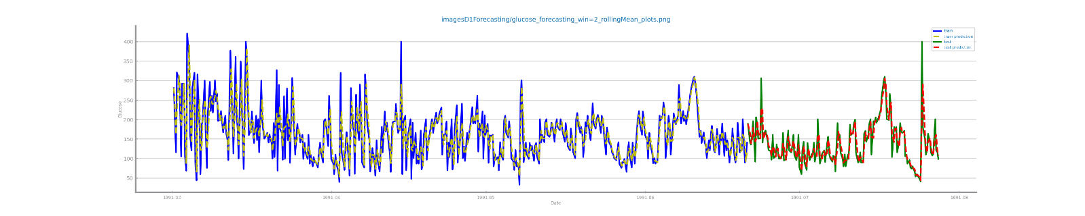

Figure 86 Forecasting plots obtained with the best parameterization of rolling mean algorithm, over time series 1



Figure 87 Forecasting results obtained with the best parameterization of rolling mean algorithm, over time series 1

Figure 88 Forecasting study over different parameterizations of the rolling mean algorithm over time series 2

Figure 89 Forecasting plots obtained with the best parameterization of rolling mean algorithm, over time series 2

Figure 90 Forecasting results obtained with the best parameterization of rolling mean algorithm, over time series 2

## ARIMA Model

The best R2 score for time series 1 was 0.01 with p=1, d=1, q=3 and for time series 2 was 0 with p=1, d=2, q=1. This may happen because the time series 1 the mean is not stationary. For time series 2 the results are explained because the data has seasonality and so it is needed to apply some transformation to make it stationary. ARIMA models assume that the time series is stationary thus the bad results.

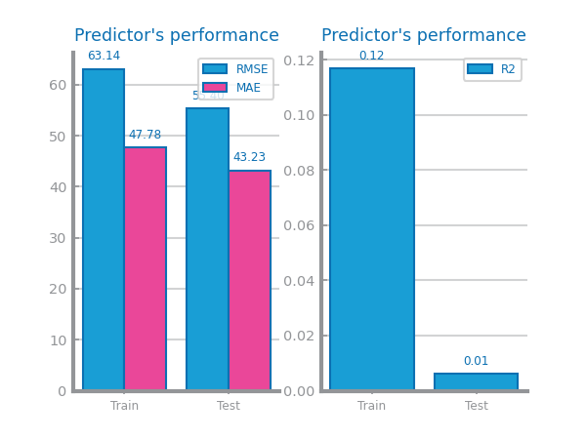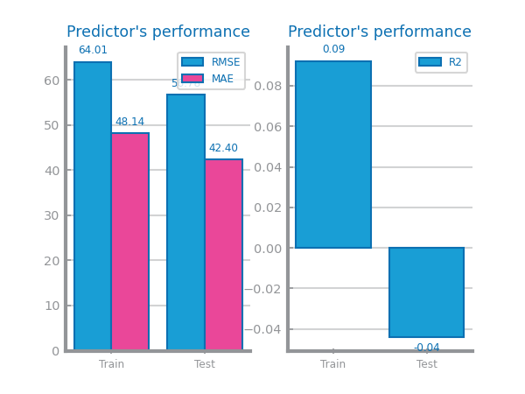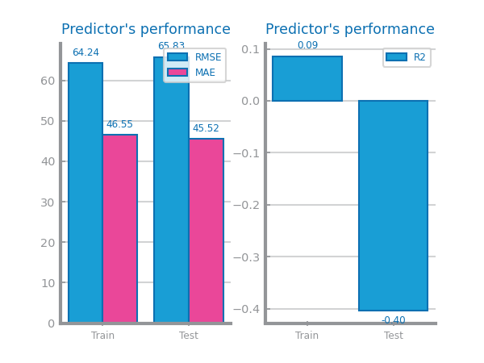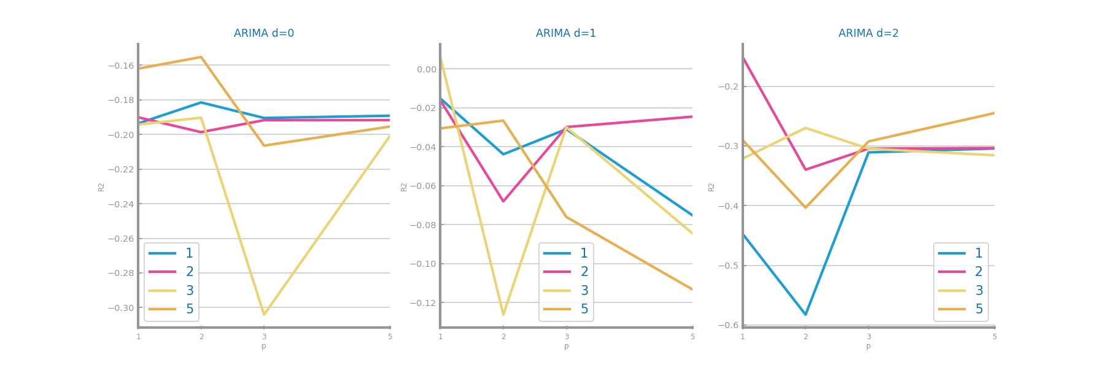

Figure 91 Forecasting study over different parameterizations of the ARIMA algorithm over time series 1

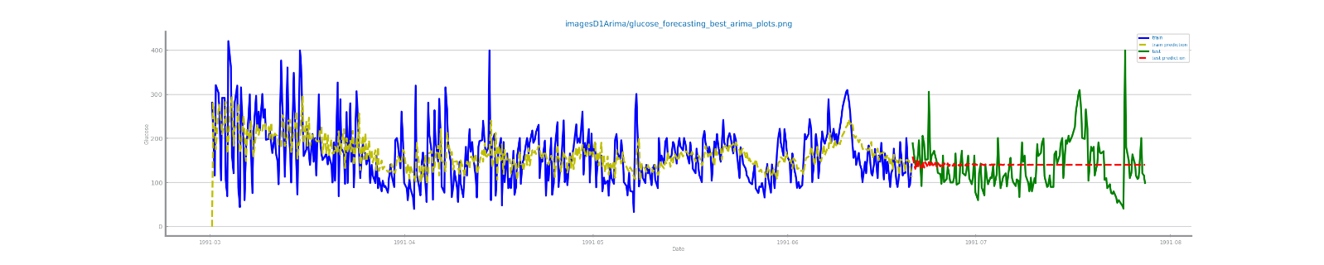

Figure 92 Forecasting plots obtained with the best parameterization of ARIMA algorithm, over time series 1



Figure 93 Forecasting results obtained with the best parameterization of ARIMA algorithm, over time series 1

Figure 94 Forecasting study over different parameterizations of the ARIMA algorithm over time series 2

Figure 95 Forecasting plots obtained with the best parameterization of ARIMA algorithm, over time series 2

Figure 96 Forecasting results obtained with the best parameterization of ARIMA algorithm, over time series 2

## LSTMs Model

For time series 1 the best R2 score was -1.17 with seq=100, hidden_size=32 and nr_episodes=2500. For time series 2 the best R2 score was 0.85 with seq=60, hidden_size=16 and nr_episodes=2500. The good results in time 2 are explained by the seasonality present because the LSTM can remember patterns from earlier in the time series so it can “remember” the previous cycle. In time series 1 this is not the case because there is no clear pattern in the data.

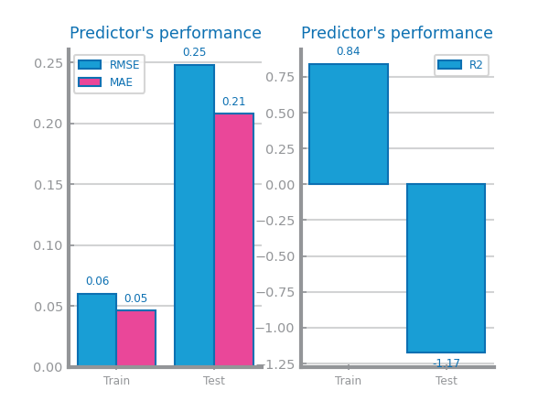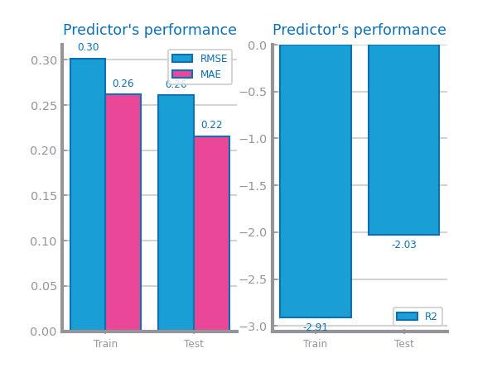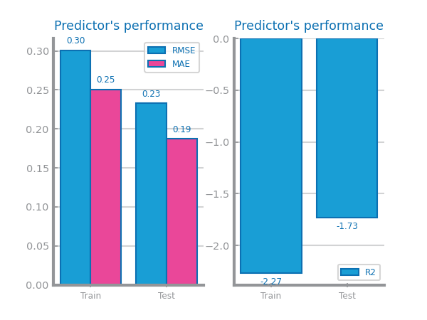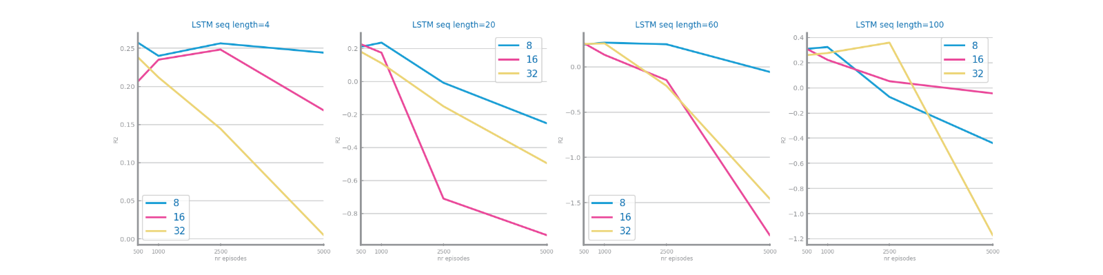

Figure 97 Forecasting study over different parameterizations of LSTMs over time series 1

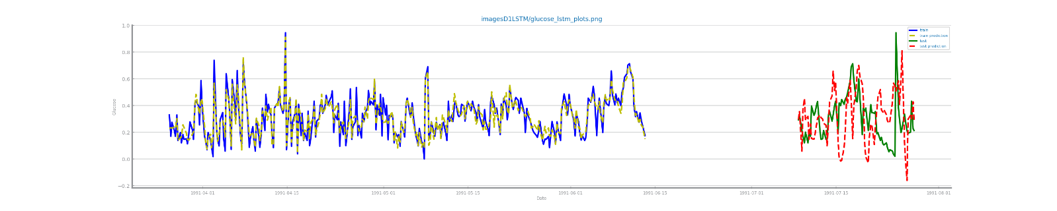

Figure 98 Forecasting plots obtained with the best parameterization of LSTMs, over time series 1



Figure 99 Forecasting results obtained with the best parameterization of LSTMs, over time series 1



Figure 100 Forecasting study over different parameterizations of the LSTMs over time series 2



Figure 101 Forecasting plots obtained with the best parameterization of LSTMs, over time series 2



Figure 102 Forecasting results obtained with the best parameterization of LSTMs, over time series 2

# Critical Analysis

For time series 1 the R2 scores are: SimpleAvg -0.19, Persistence Model -0.03, Rolling Mean 0.74, ARIMA 0.01, LSTM -1.17.

For time series 2 the R2 scores are: SimpleAvg -0.01, Persistence Model 0.80, Rolling Mean 0.95, ARIMA 0, LSTM 0.85.

The results overall for time series 1 were bad this is because the time series mean is not stationary and it doesn’t have clear patterns in the data. This dataset describes the glucose level over time so it isn’t easy to forecast like the time series 2 for example which is a weather related dataset and has clear seasonality.

The time series 2 results were generally good except for the simpleAvg and ARIMA models. The simpleAVG got a bad result because it simply predicts the average value and the ARIMA model assumes that the time series is stationary and this time series was not stationary because it had seasonality, to become stationary and get better results on this model we could apply a transformation like the difference of the data. The best models were the rolling mean and LSTM the LSTM results can be explained by the fact that this model can “remember” patterns so this in combination with the seasonality of the time series produced a good result.

For time series 1 no model seems to be good enough but for time series 2 the LSTM model seems to be good enough with a R2 score of 0.85. The rolling mean model with window size of 2 also seems to be a good model for the time series 2 but we would not recommend it’s use because it is too overfitted.